MODULE 11:- Ansible

Configuration Automation using Ansible
SUBMITTED BY :- CHANDAN YADAV KS
SUBMITTED TO :- VIKUL
DATE OF SUBMISSION :- 17-07-2025

1. L1 - Create and Execute Ansible Playbook to Setup Java Maven Application Build Server
Step1: INSTALLING AND CONFIGURING ANSIBLE
i)lunch 3 instance(1 is ansible server and 2 is node)
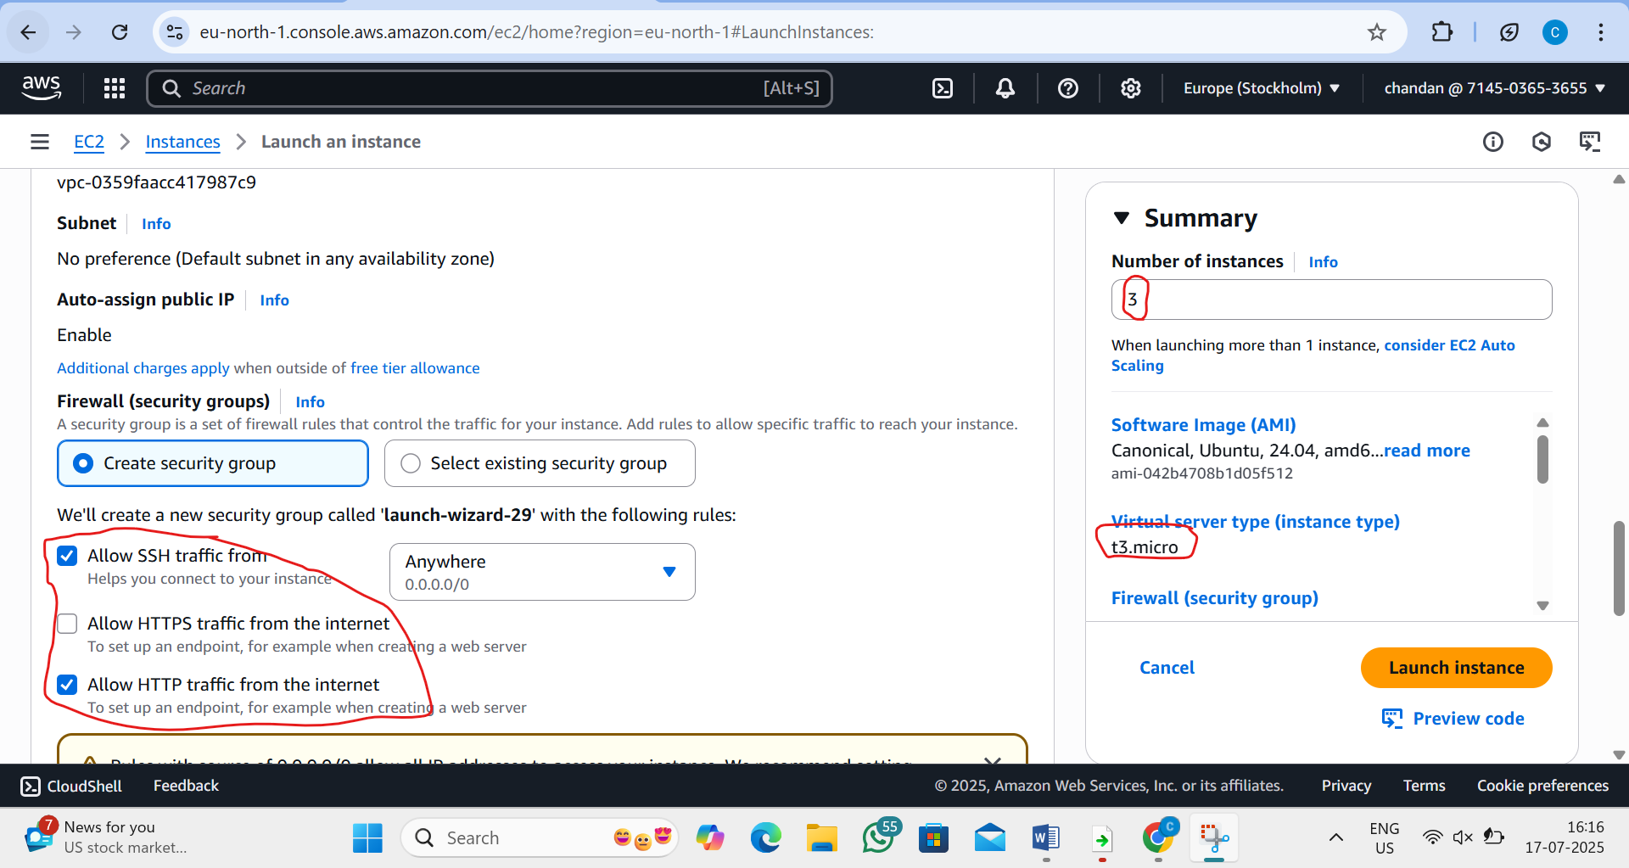
ii)name the instance
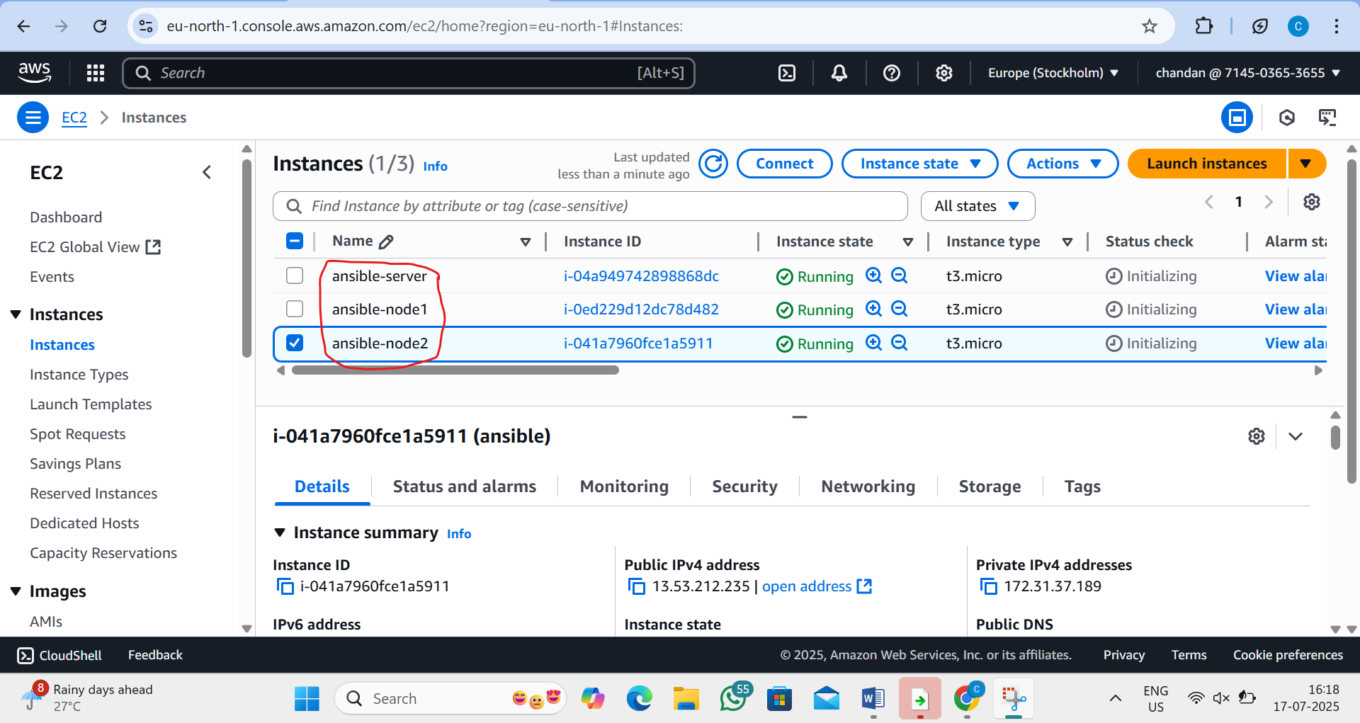

iii)now connect the ansible-server machine to the browser
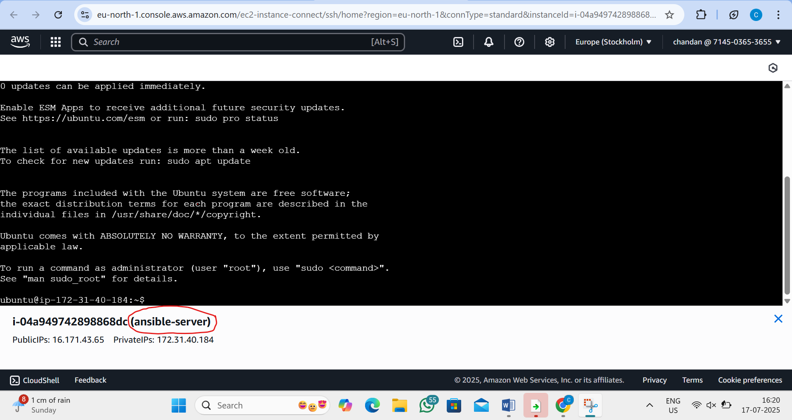
iv)similary connect node1 and node2 machine(in screenshot I will disply only node 1)
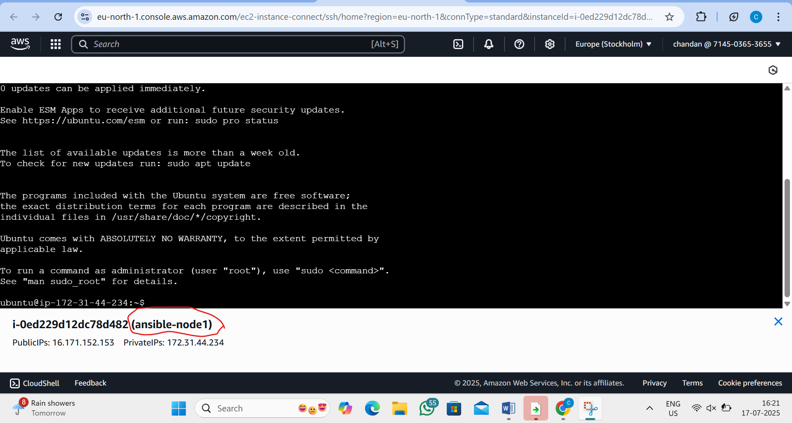

v)now open ansible-server machine instance and go to root user
by the command:-sudo su
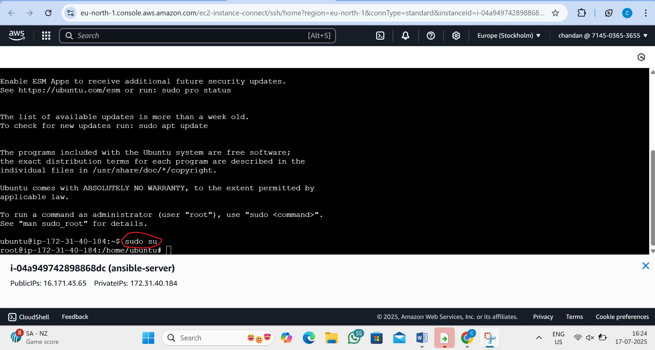
vi) lets now install ansible in ansible server
by the command:- 1)apt update -y
2) apt-get install -y software-properties-common
3)apt-add-repository ppa:ansible/ansible
4)apt-get update
5) apt-get install -y ansible
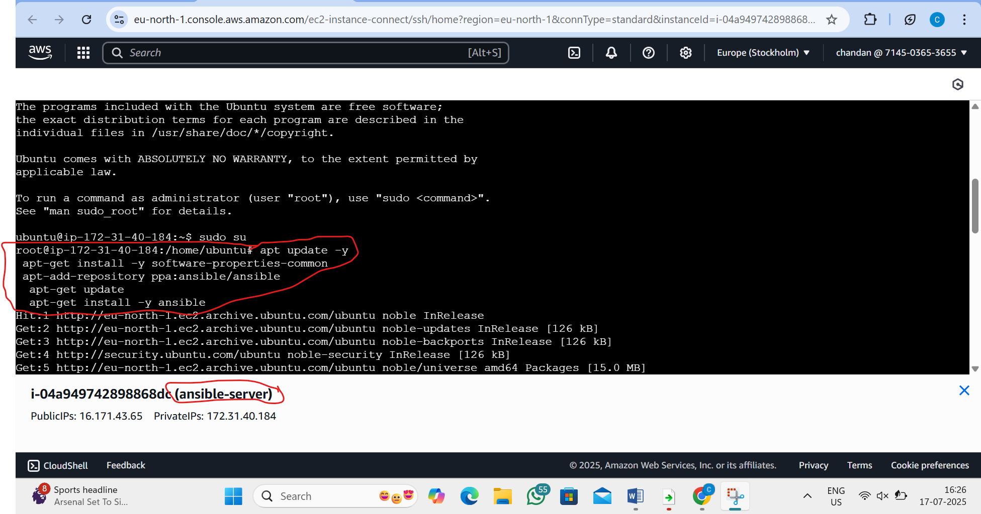

vii)we will now define the hosts from the master machine (ansible server)
by the command:- vi /etc/ansible/hosts
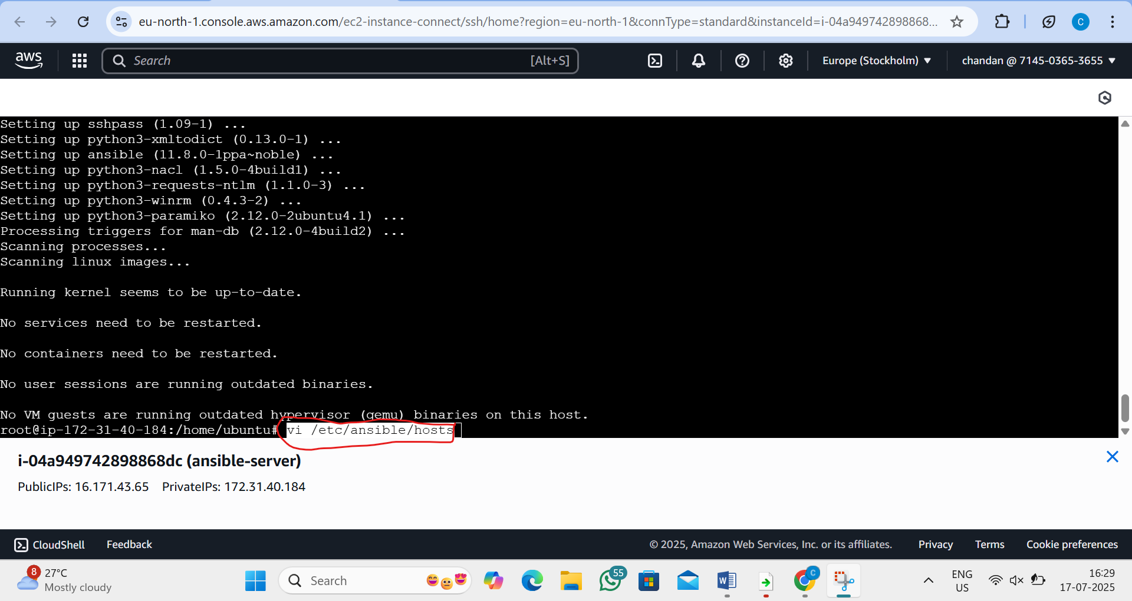
viii)inside that we want to copy and paste the private ip of node1 and node2
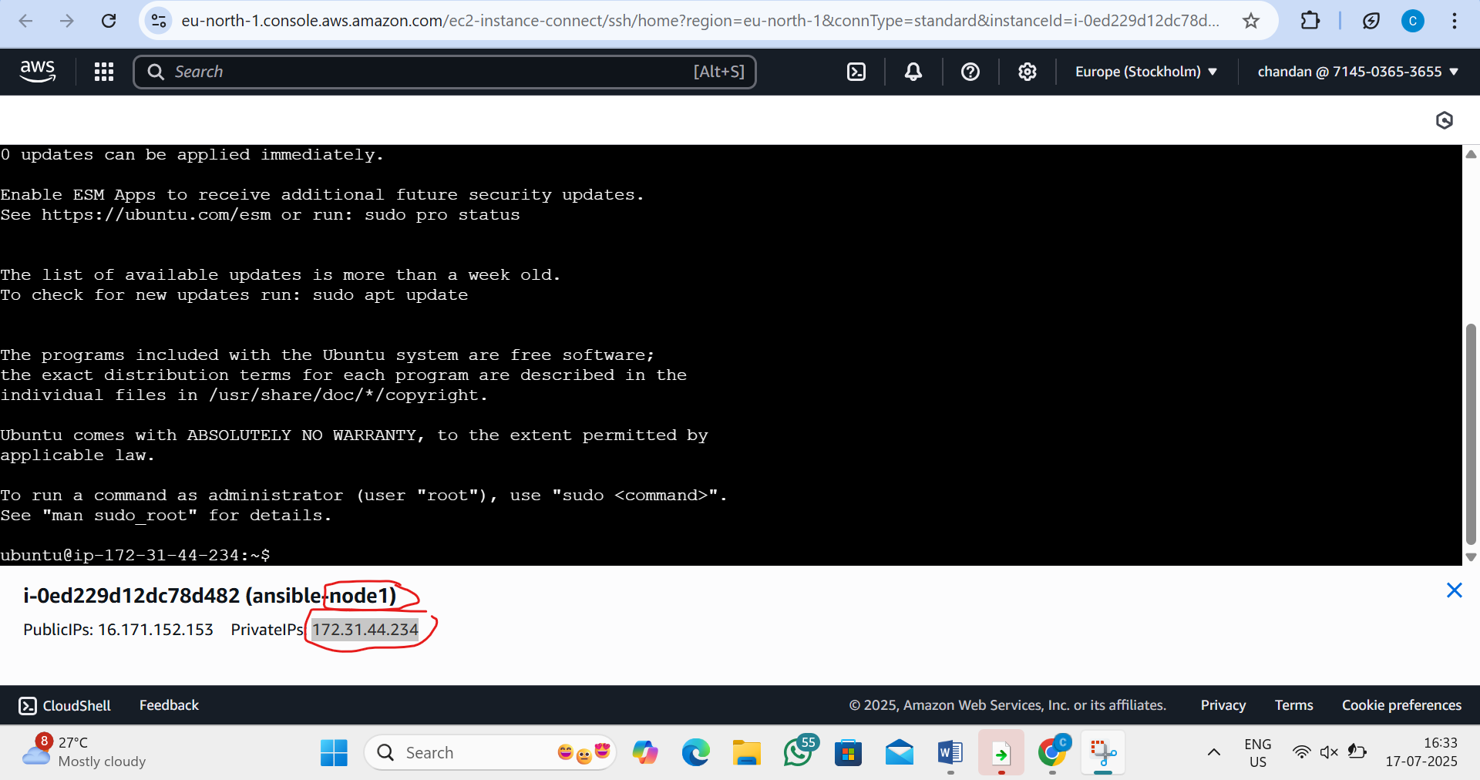

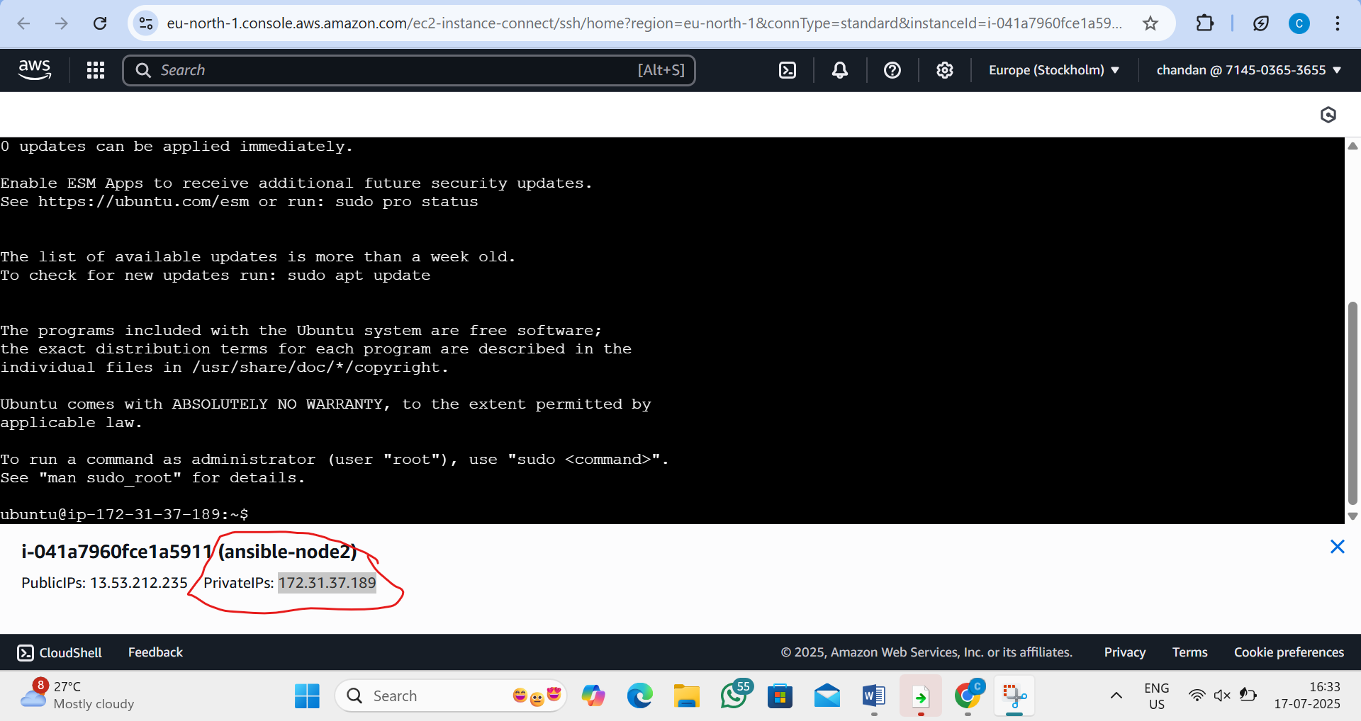

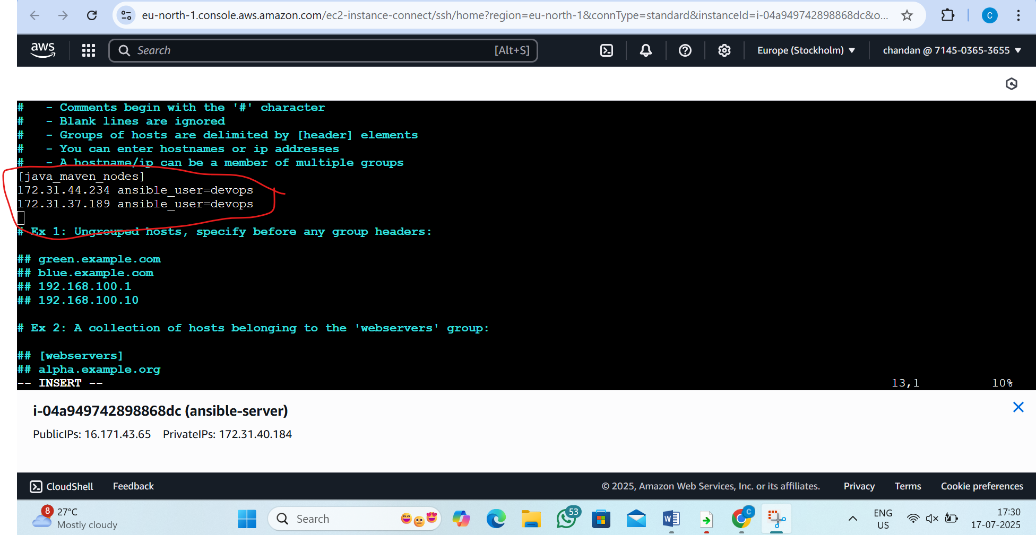

ix) Create a user in Ansible server (master machine) and the nodes
by the command:-adduser devops
and type the password
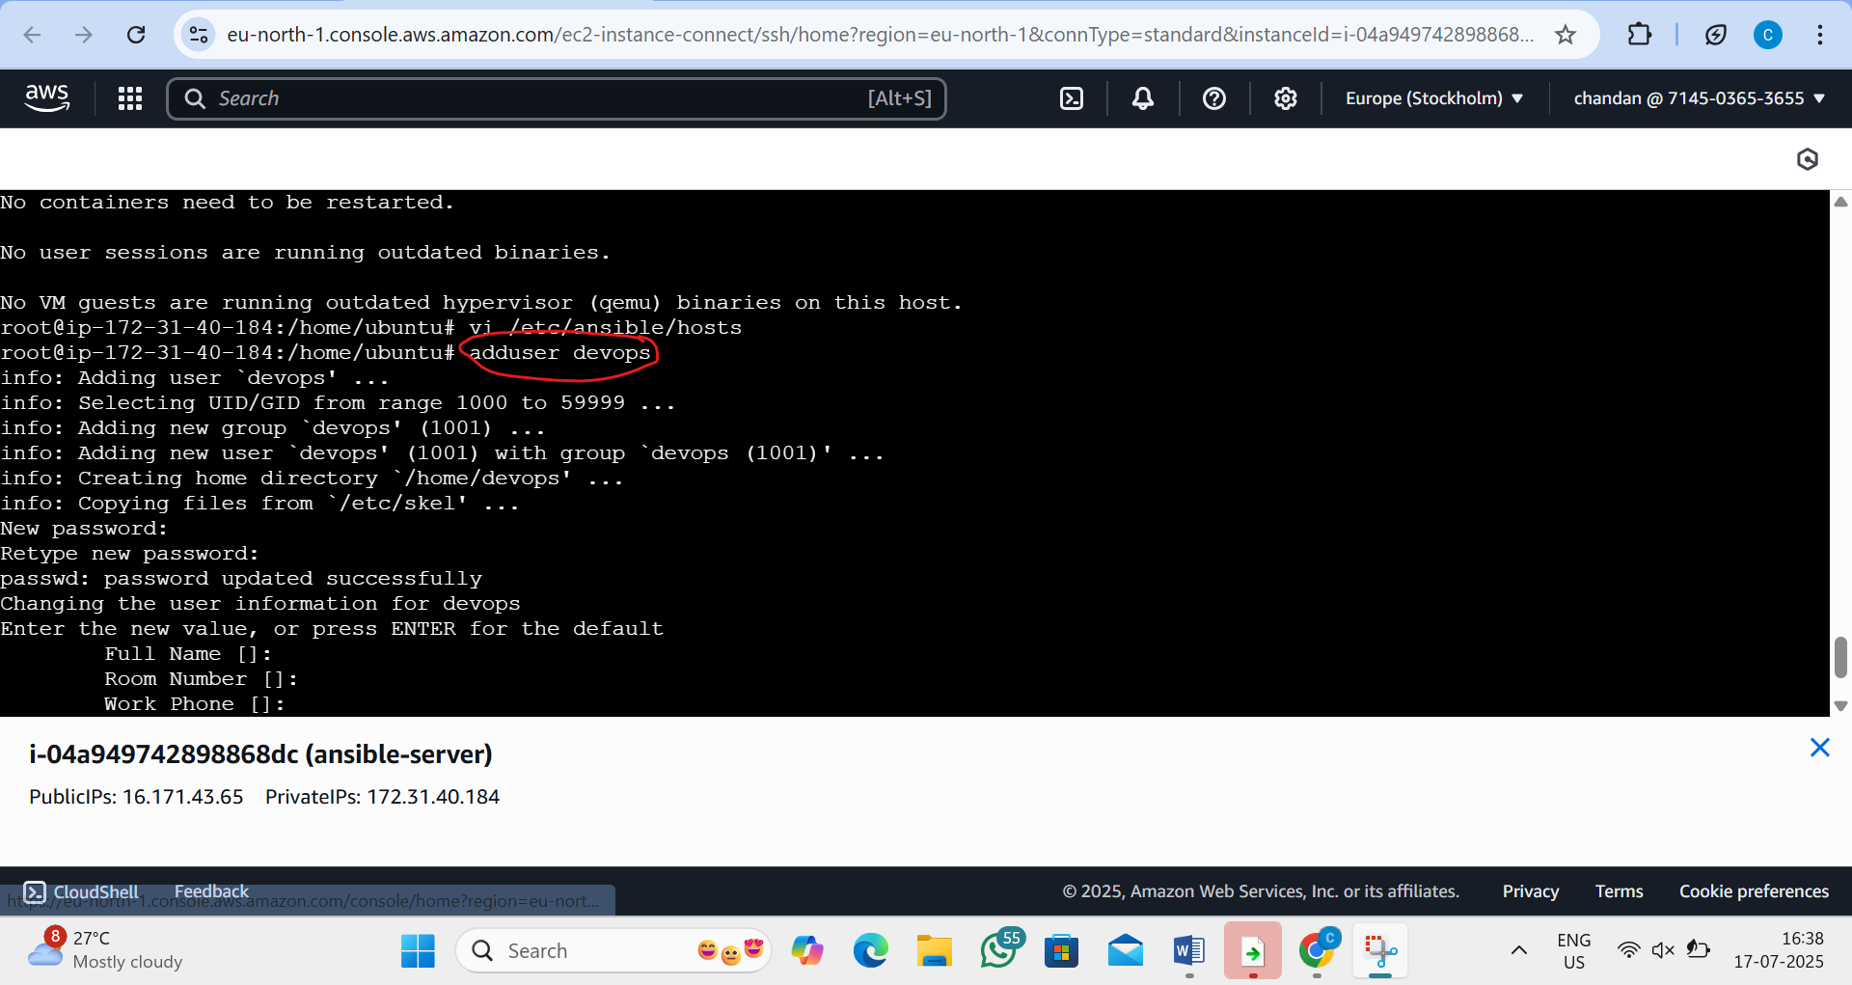
x) Similary create the same username and pass In the nodes as well
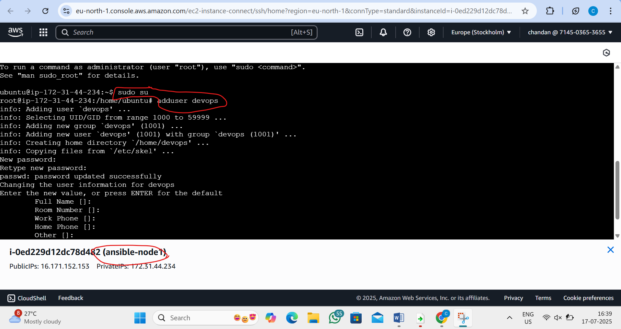

xi) We will now configure sshd configuration in master and node machines
by the command:- vi /etc/ssh/sshd_config
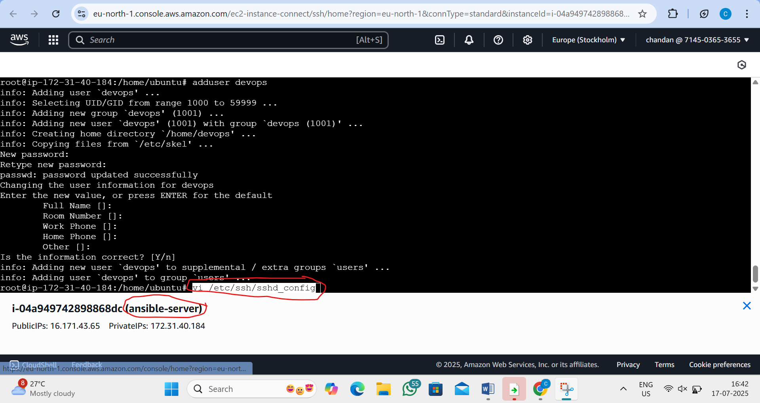

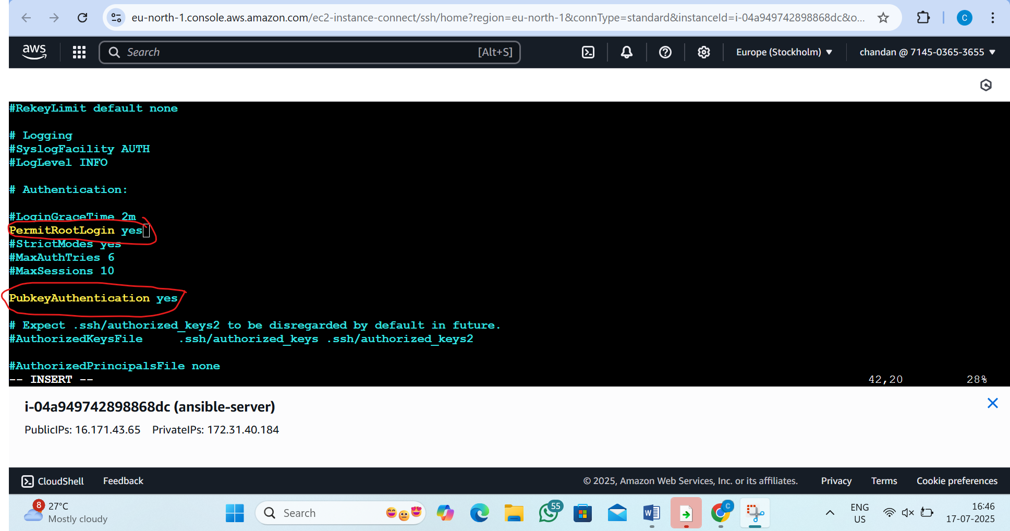

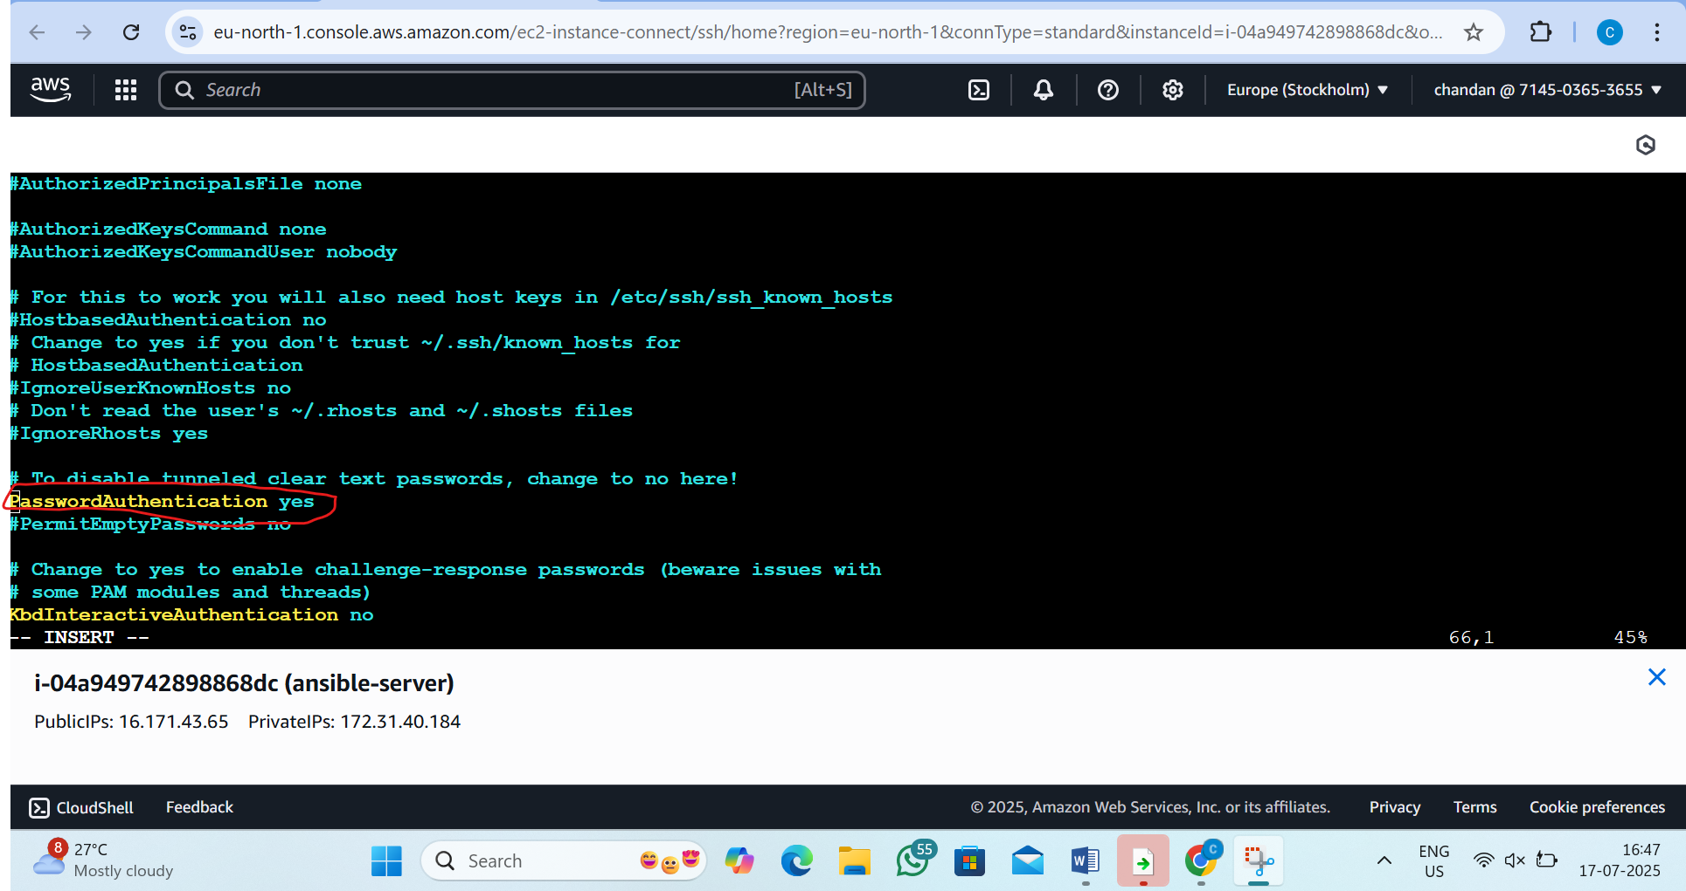
Do this for node machine also

Xii) Change password authentication to yes(do this fo all 3 machine also)
By the command:- #vi /etc/ssh/sshd_config.d/60-cloudimg-settings.conf
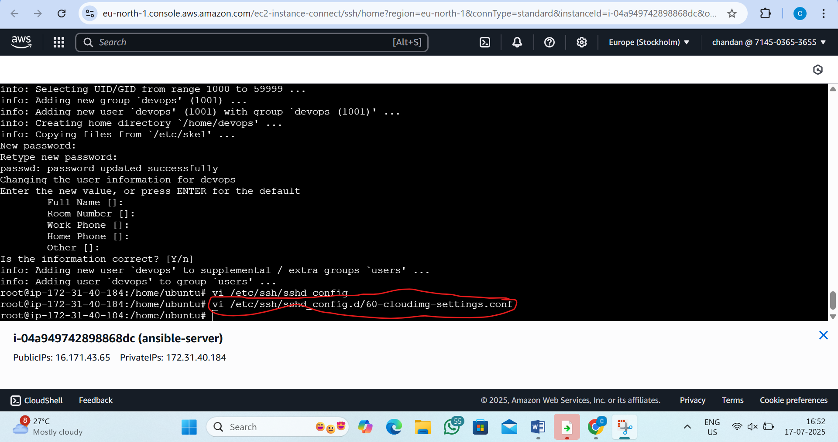
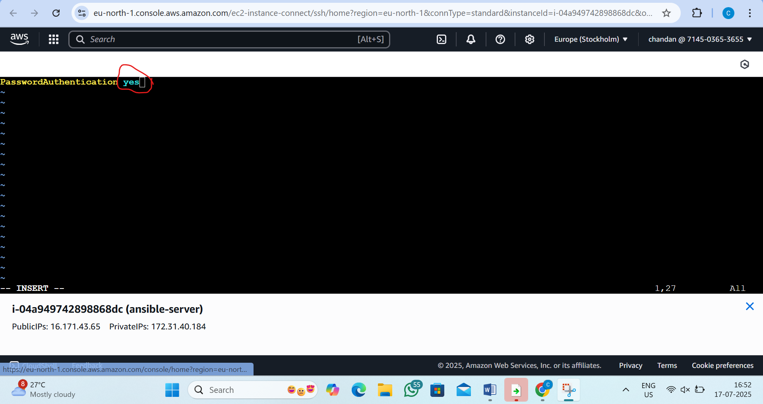
xiii) service ssh restart
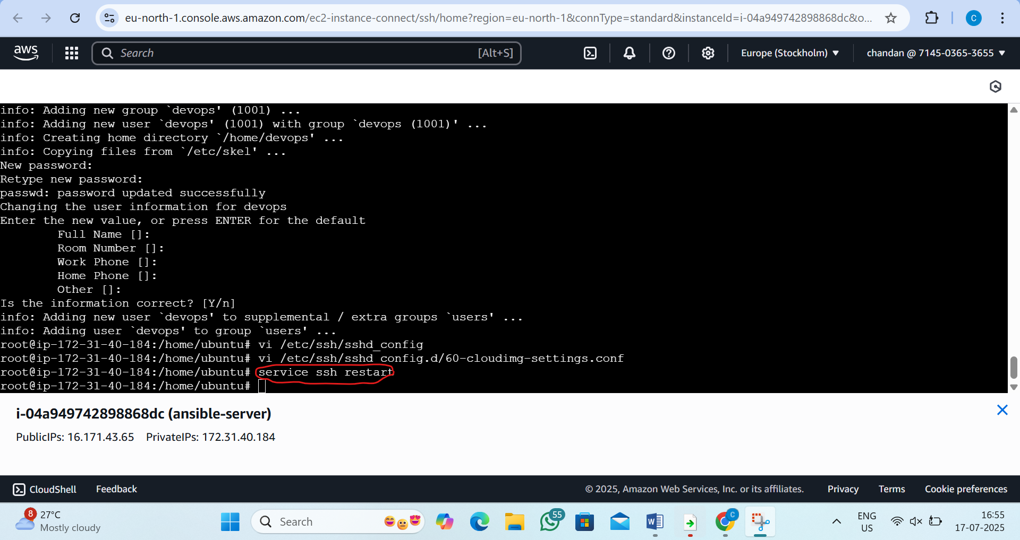

xiv) We will now give sudo permission to the “devops” user in ansible and the nodes
by the command:-visudo
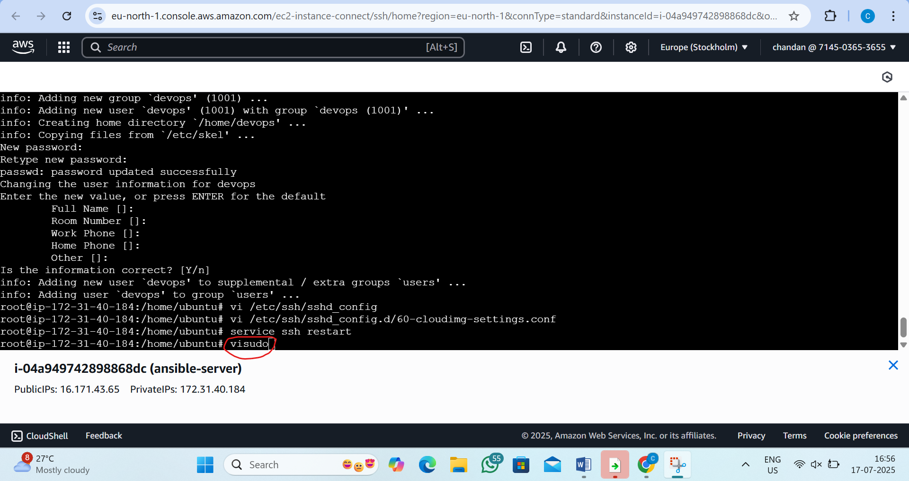
xv)add this inside and press ctrl x and ctrl y and enter(do this for all 3 machine)
devops ALL=(ALL:ALL) NOPASSWD:ALL
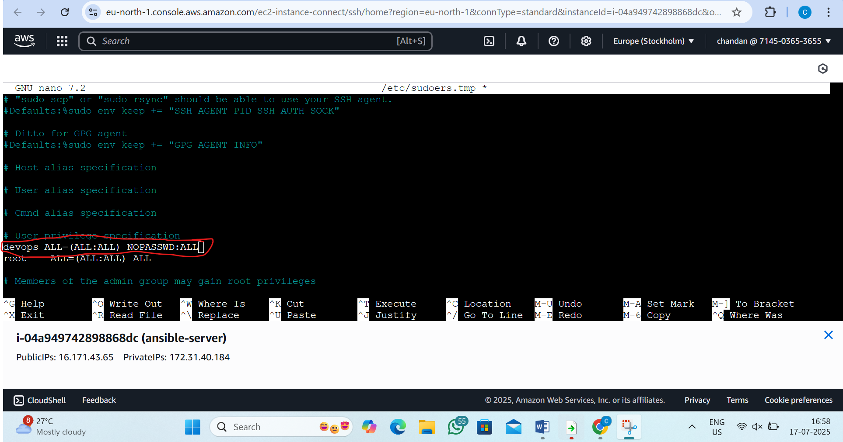

xvi) From Ansible server we will generate the trust relationship(we will generate a key in the master and paste it in the ansible nodes to establish the ssh connection w/o putting password) with the nodes
in master machine follow the command
command:- 1)su – devops
2)ssh-keygen

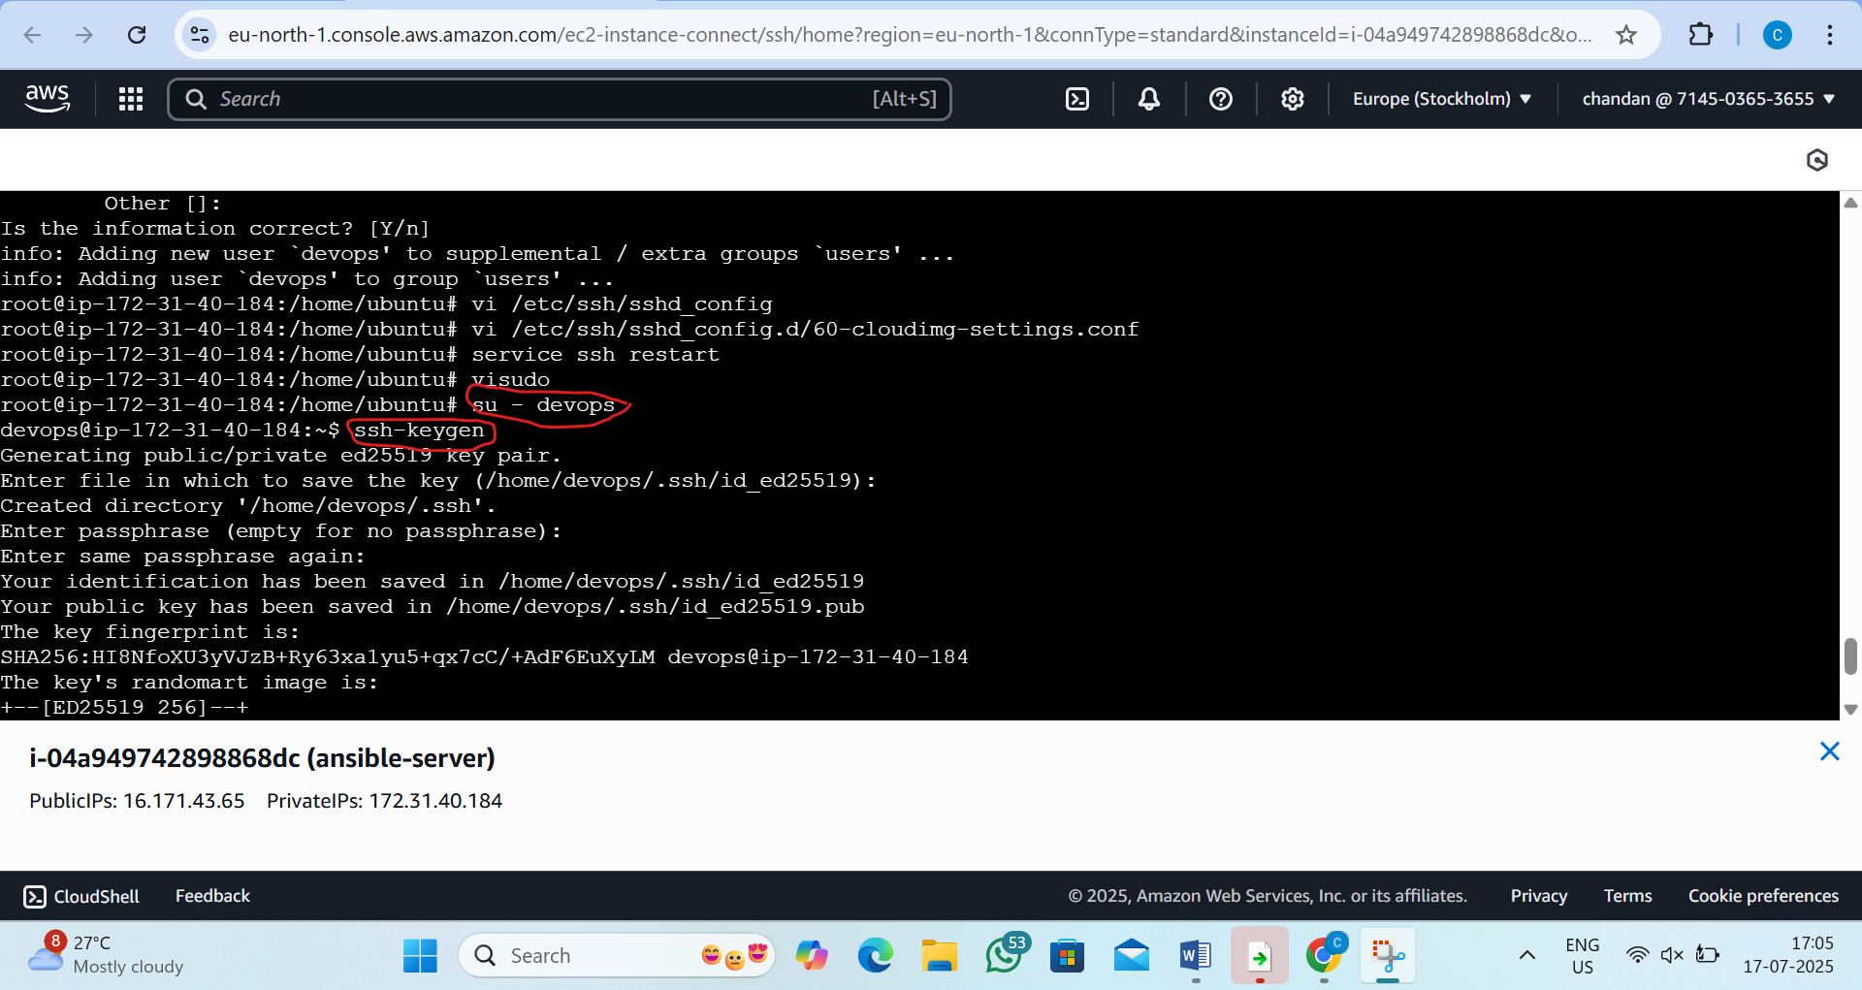
xvii)pass the command in master
command is ;- 1) ls -a
2)cd .ssh
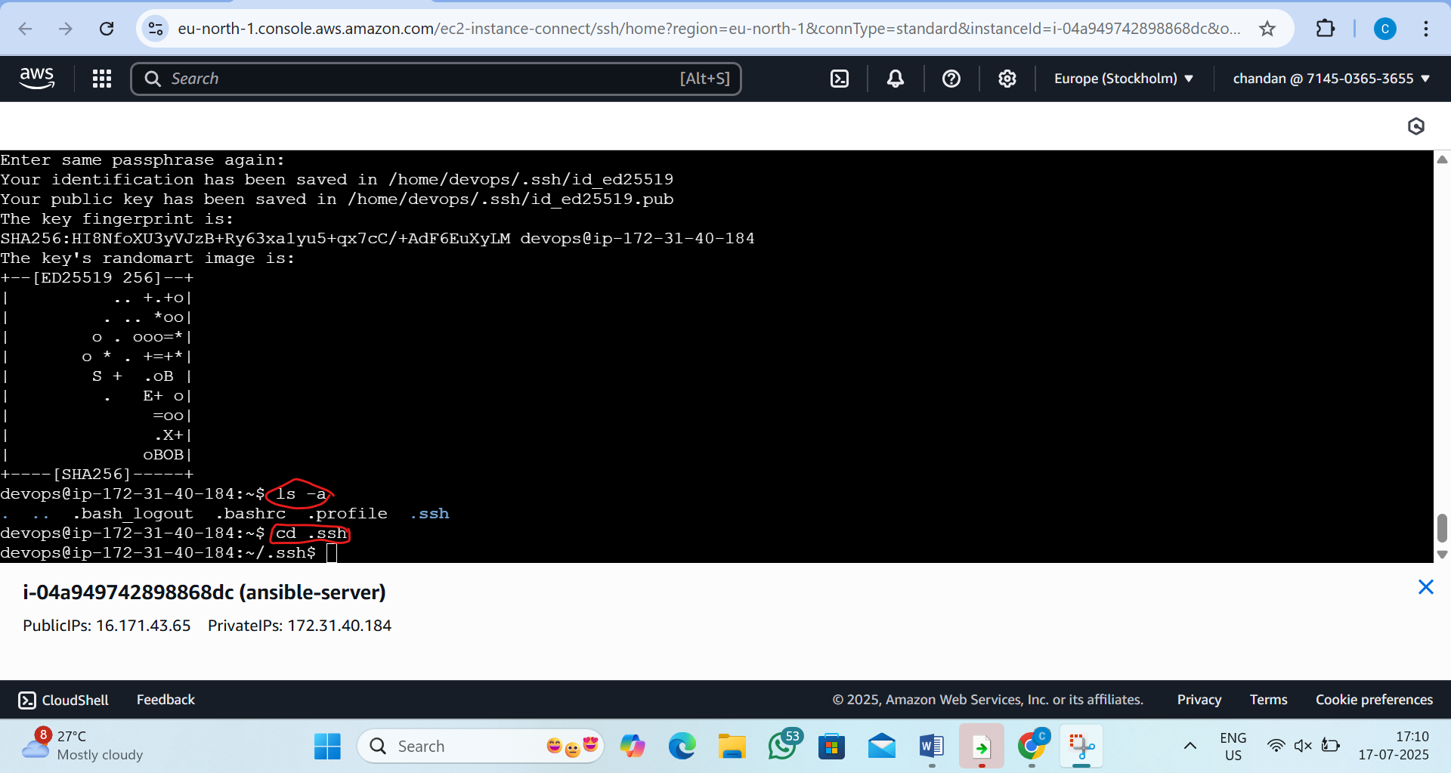
xviii)now copy the private ip of node 1 and node 2 and pass the command like this ssh-copy-id devops@privateipofnode1
NODE1
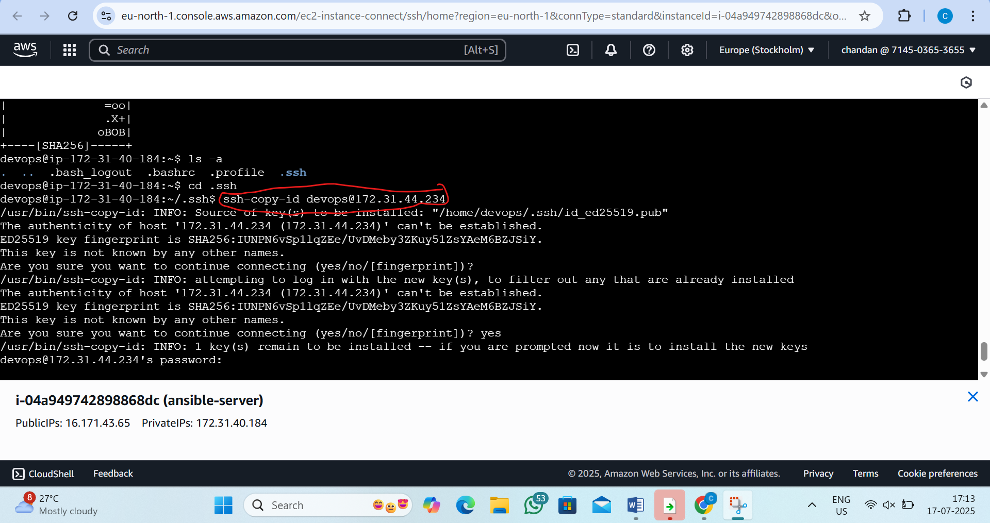
NODE2
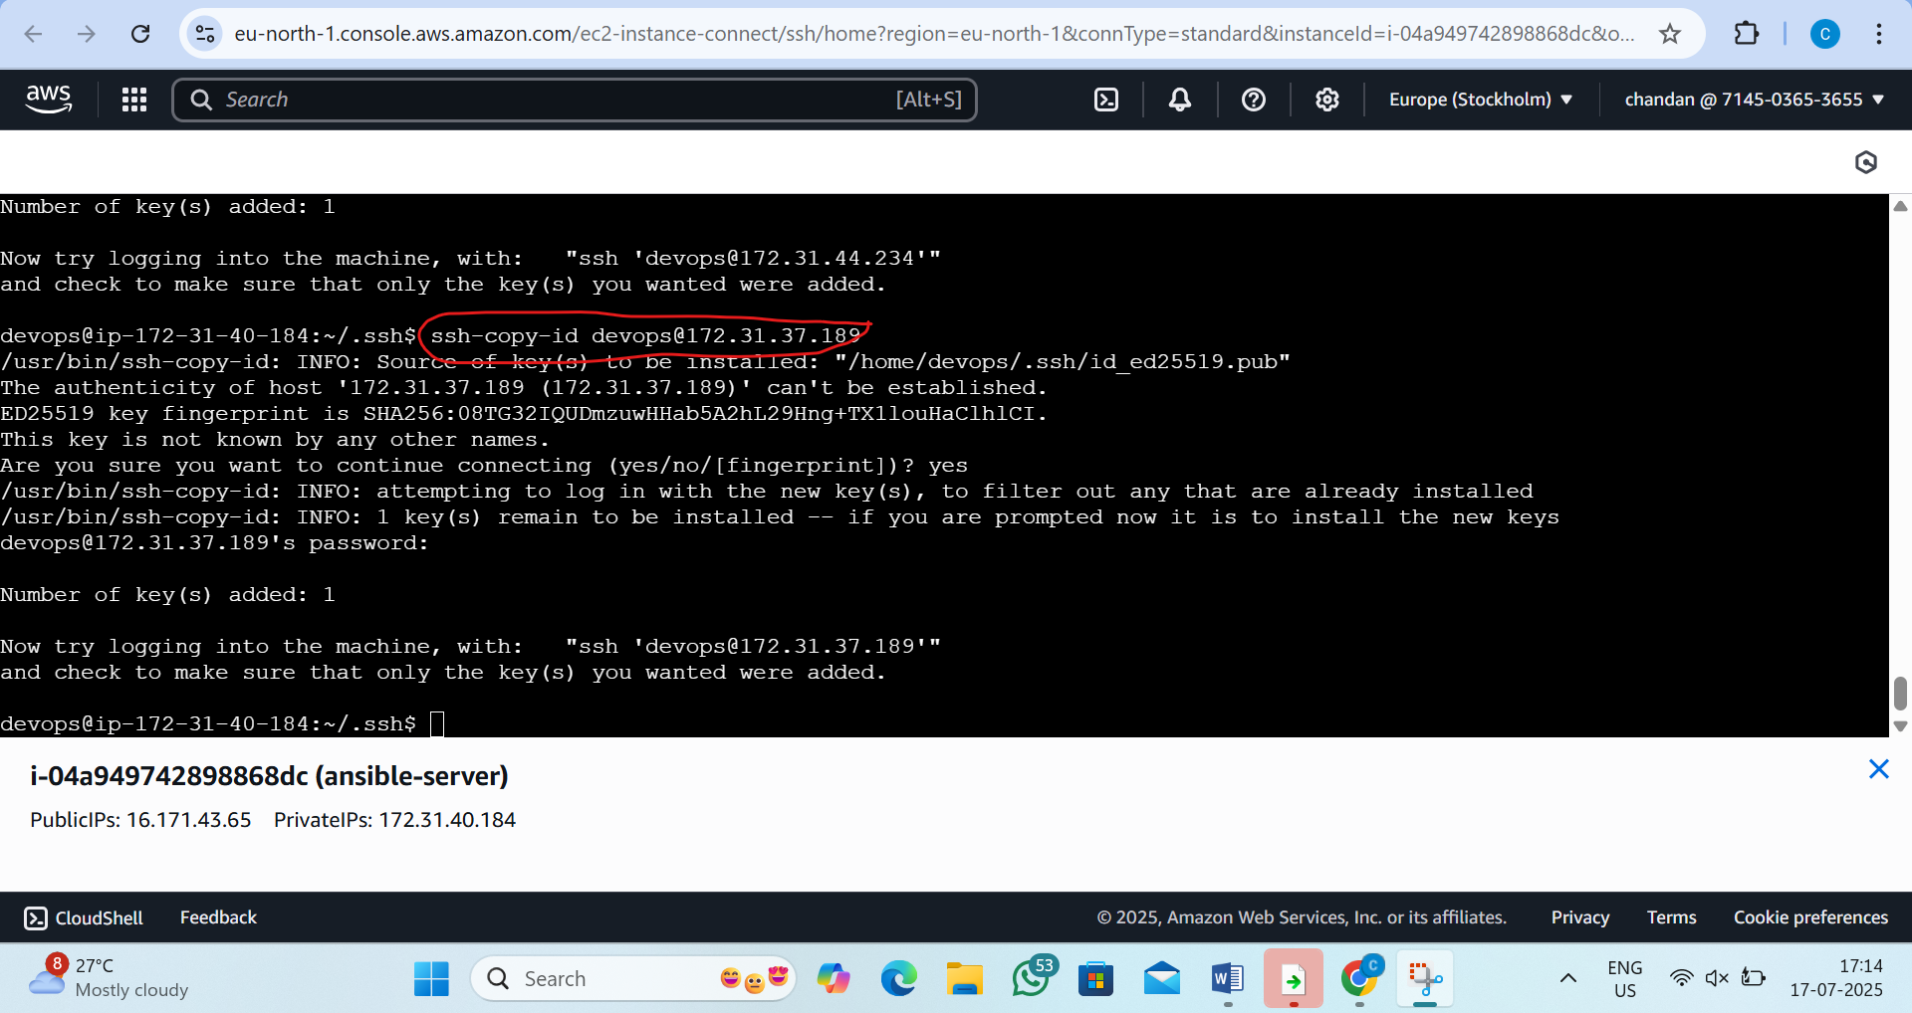

STEP2: create ansible playbook
By the command:1) vi java-maven-setup.yml
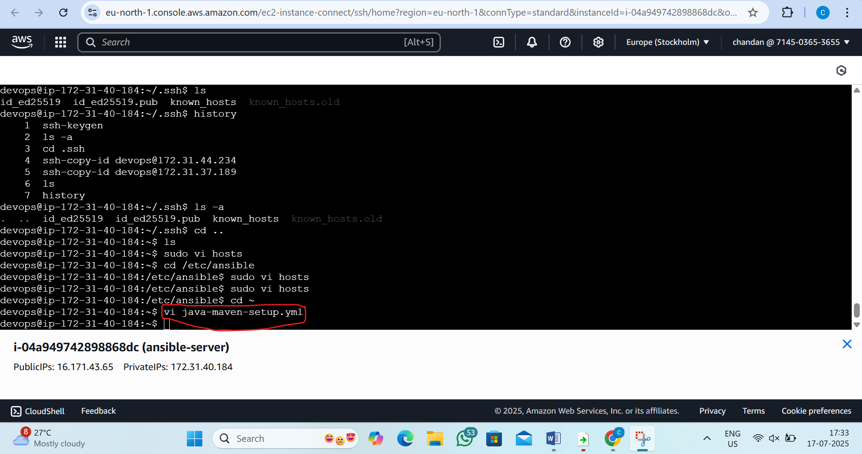
Step3:paste the script inside
---
- name: Setup Java Maven Application Build Server
hosts: java_maven_nodes
become: yes
tasks:
- name: Update package list
command: apt update

- name: Install OpenJDK 17
command: apt install -y openjdk-17-jdk

- name: Install Maven
command: apt install -y maven

- name: Verify Java installation
command: java -version

- name: Verify Maven installation
command: mvn -version
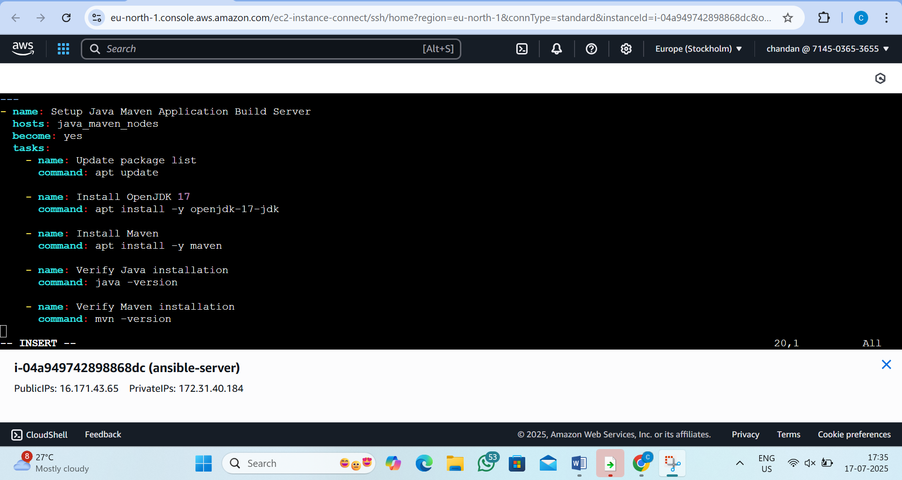

Step4:run the playbook
by the command:- ansible-playbook java-maven-setup.yml
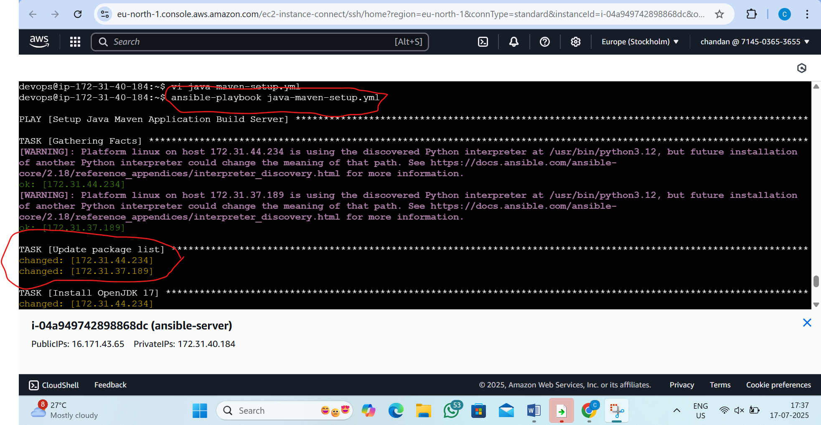

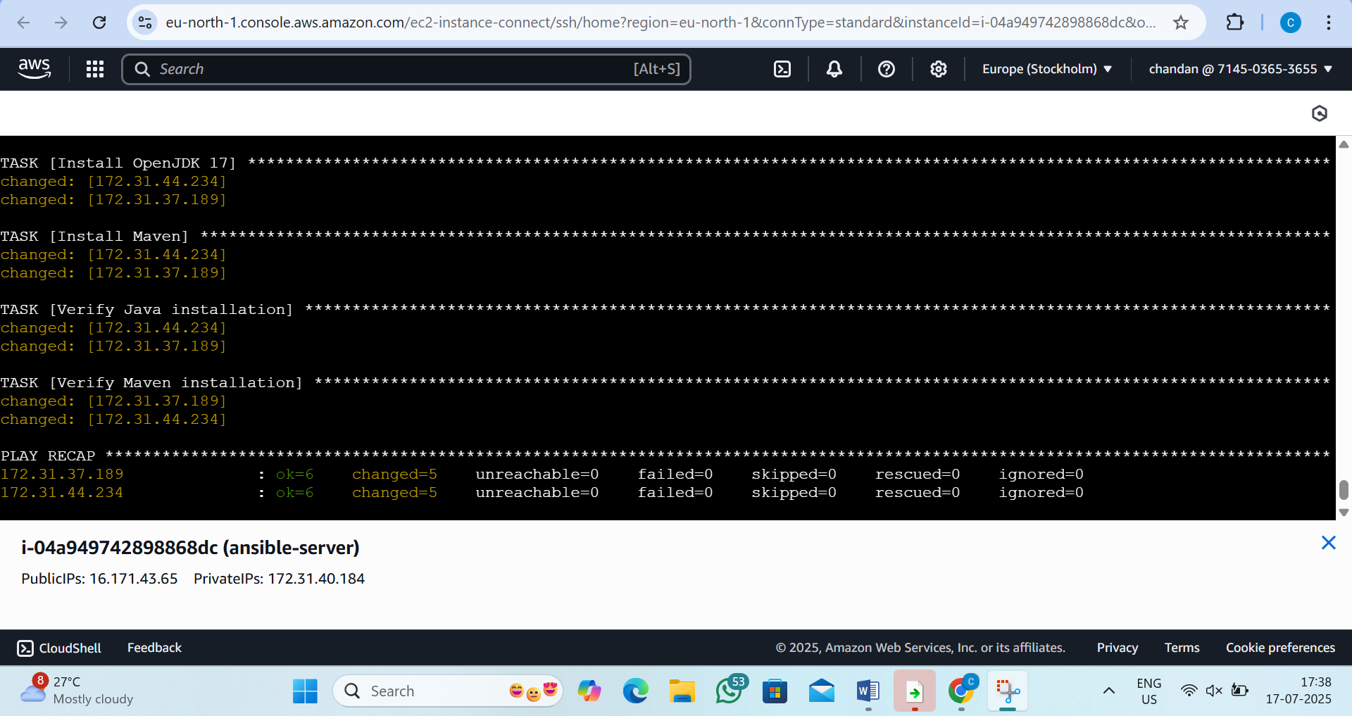

2. L2 - Create and Execute Ansible Playbook to Install Docker and Run the Docker Application Image created in Docker Module
step1: Create Ansible Playbook File
By the command: vi docker-install-run.yml
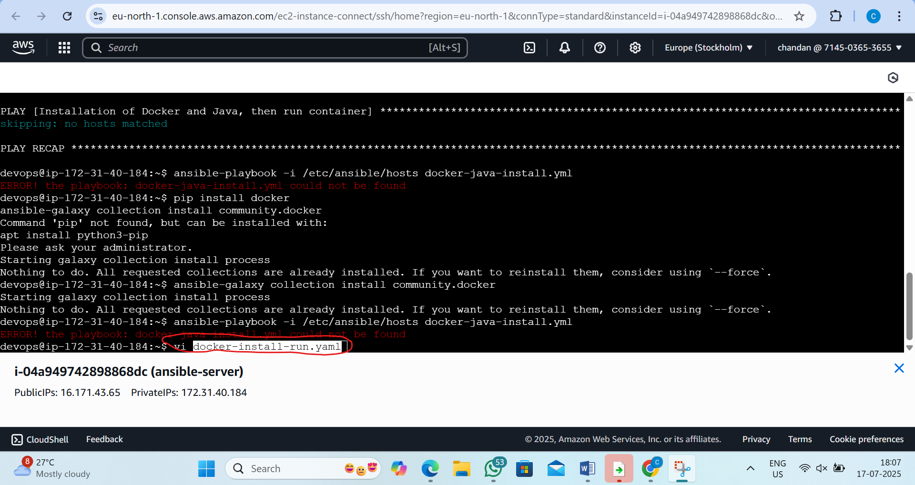

Step2:paste this script inside
---
- name: Install Docker and Run Application Image
hosts: docker_nodes
become: yes
tasks:

- name: Update APT packages
apt:
update_cache: yes

- name: Install required packages
apt:
name: "{{ item }}"
state: present
loop:
- apt-transport-https
- ca-certificates
- curl
- software-properties-common

- name: Add Docker GPG key
apt_key:
url: https://download.docker.com/linux/ubuntu/gpg
state: present

- name: Add Docker repository
apt_repository:
repo: deb https://download.docker.com/linux/ubuntu focal stable
state: present

- name: Install Docker CE
apt:
name: docker-ce
state: present
update_cache: yes

- name: Ensure Docker is started
service:
name: docker
state: started
enabled: yes

- name: Pull Docker image (httpd as example)
docker_image:
name: httpd
source: pull

- name: Run Docker container
docker_container:
name: webserver
image: httpd
state: started
ports:
- "8080:80"
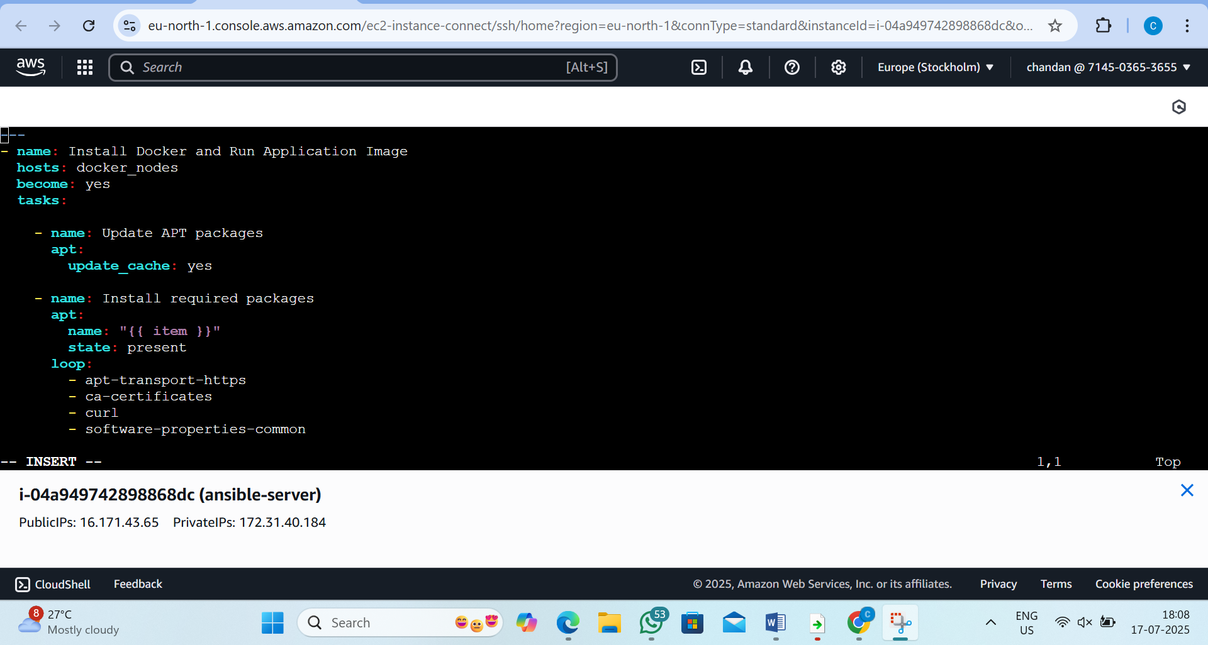

Step3: Run the Ansible Playbook
by the command:- ansible-playbook docker-install-run.yaml
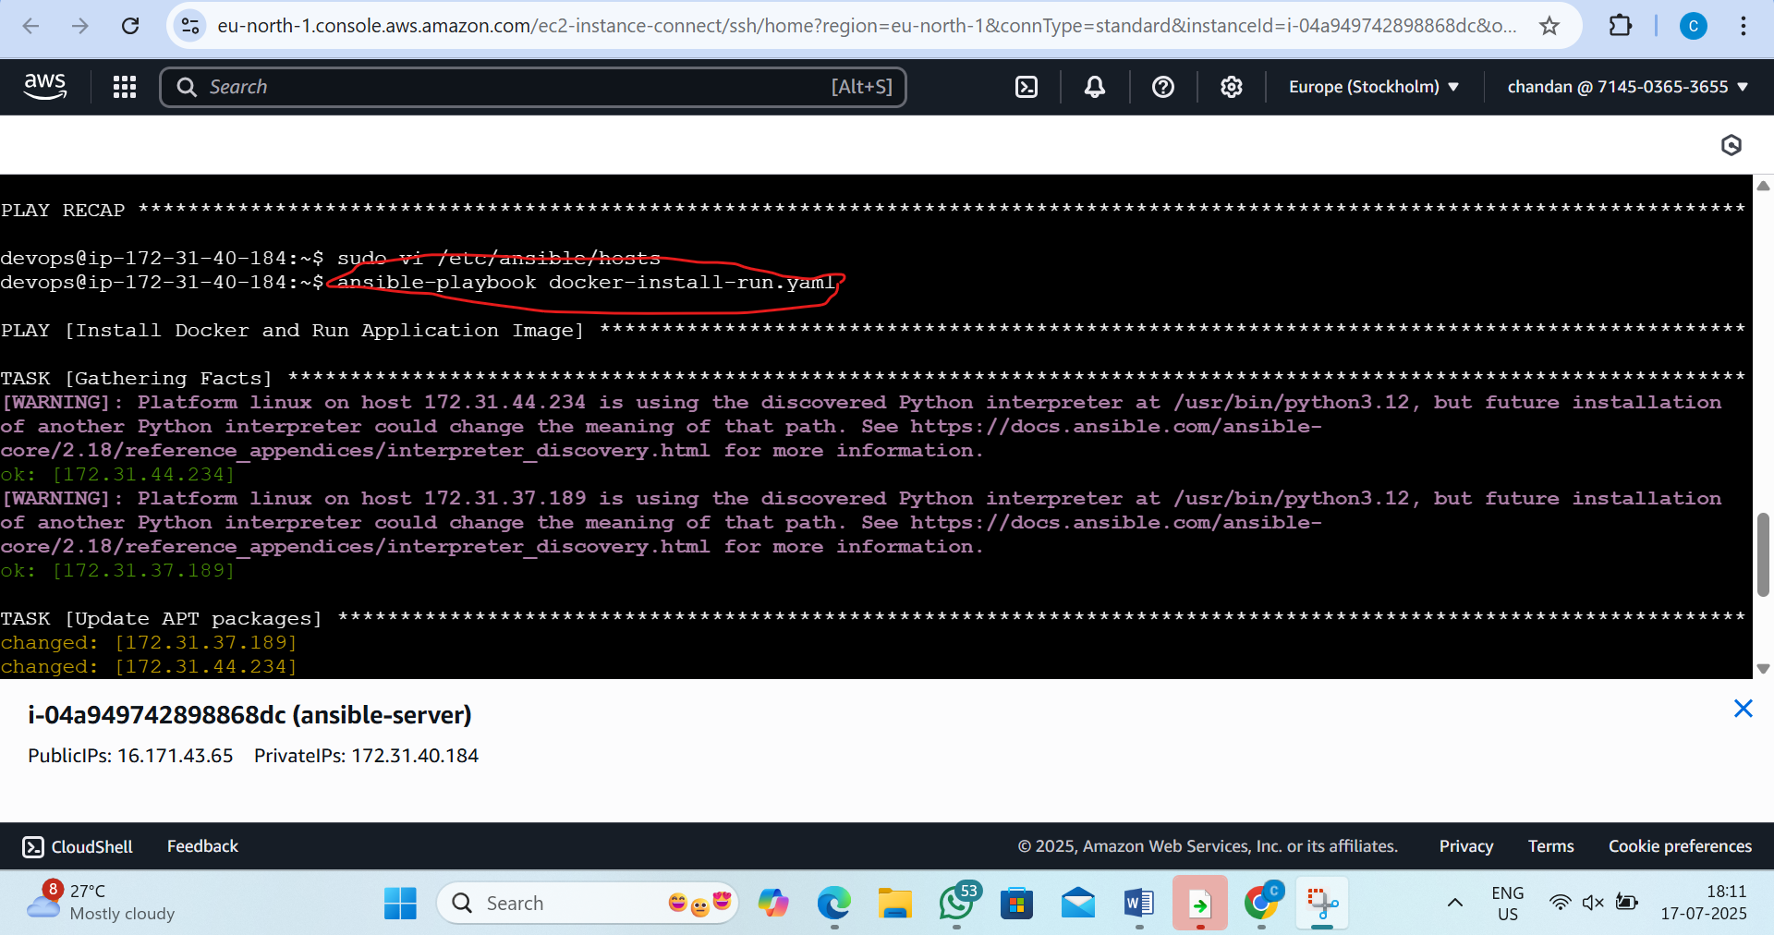

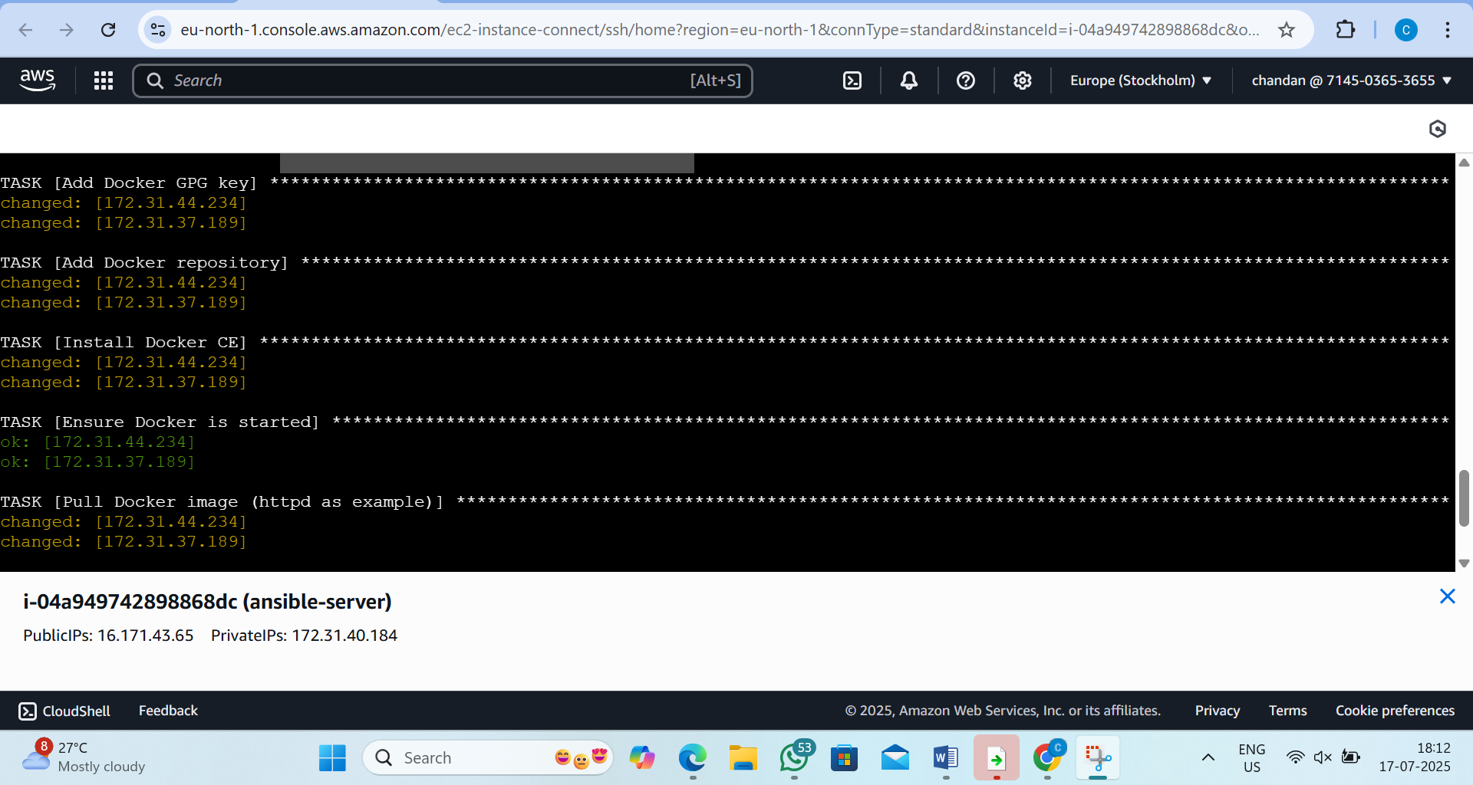

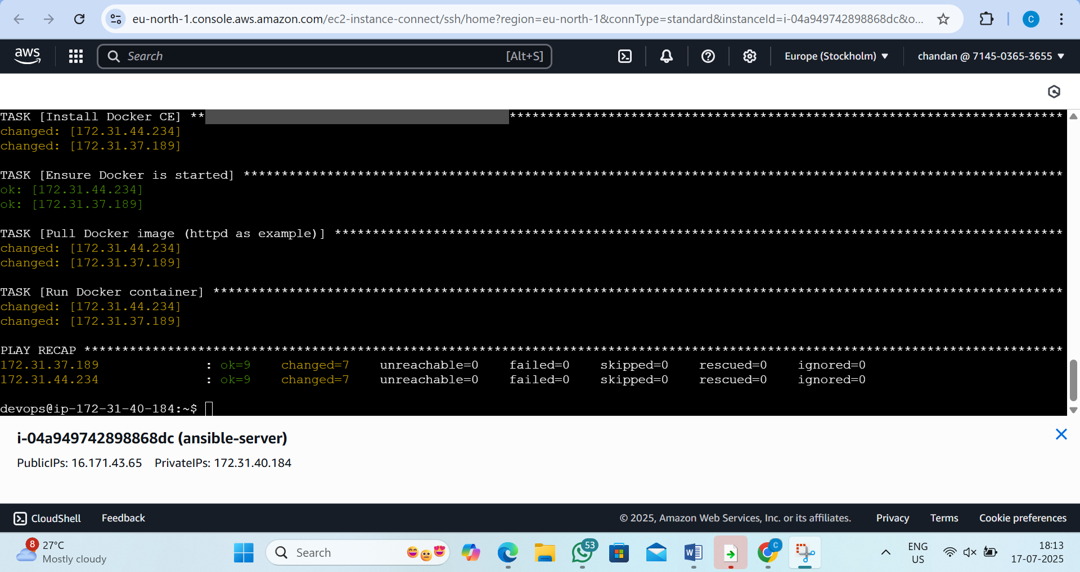

Step4:add 8080 port in security group
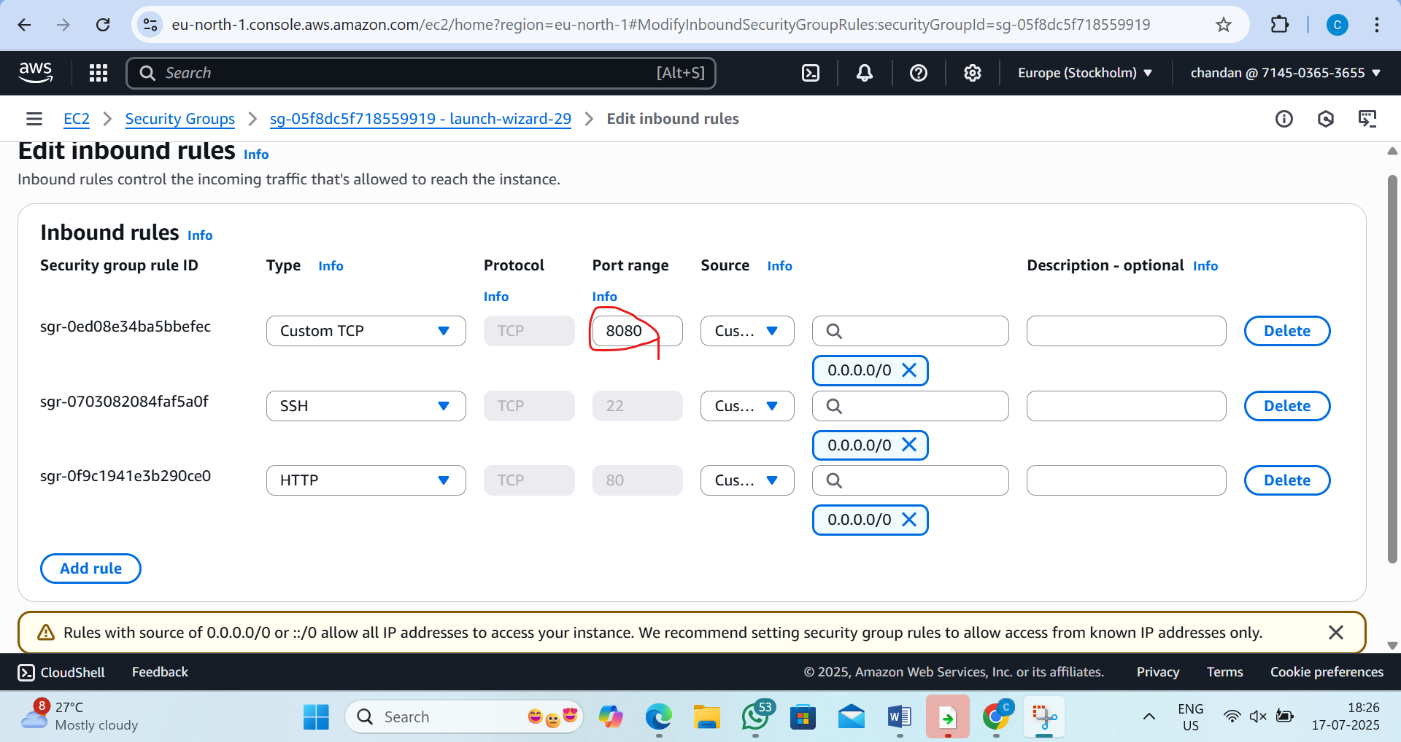

Step5: Access the App in Browser
type:- http://<Node Public IP>:8080
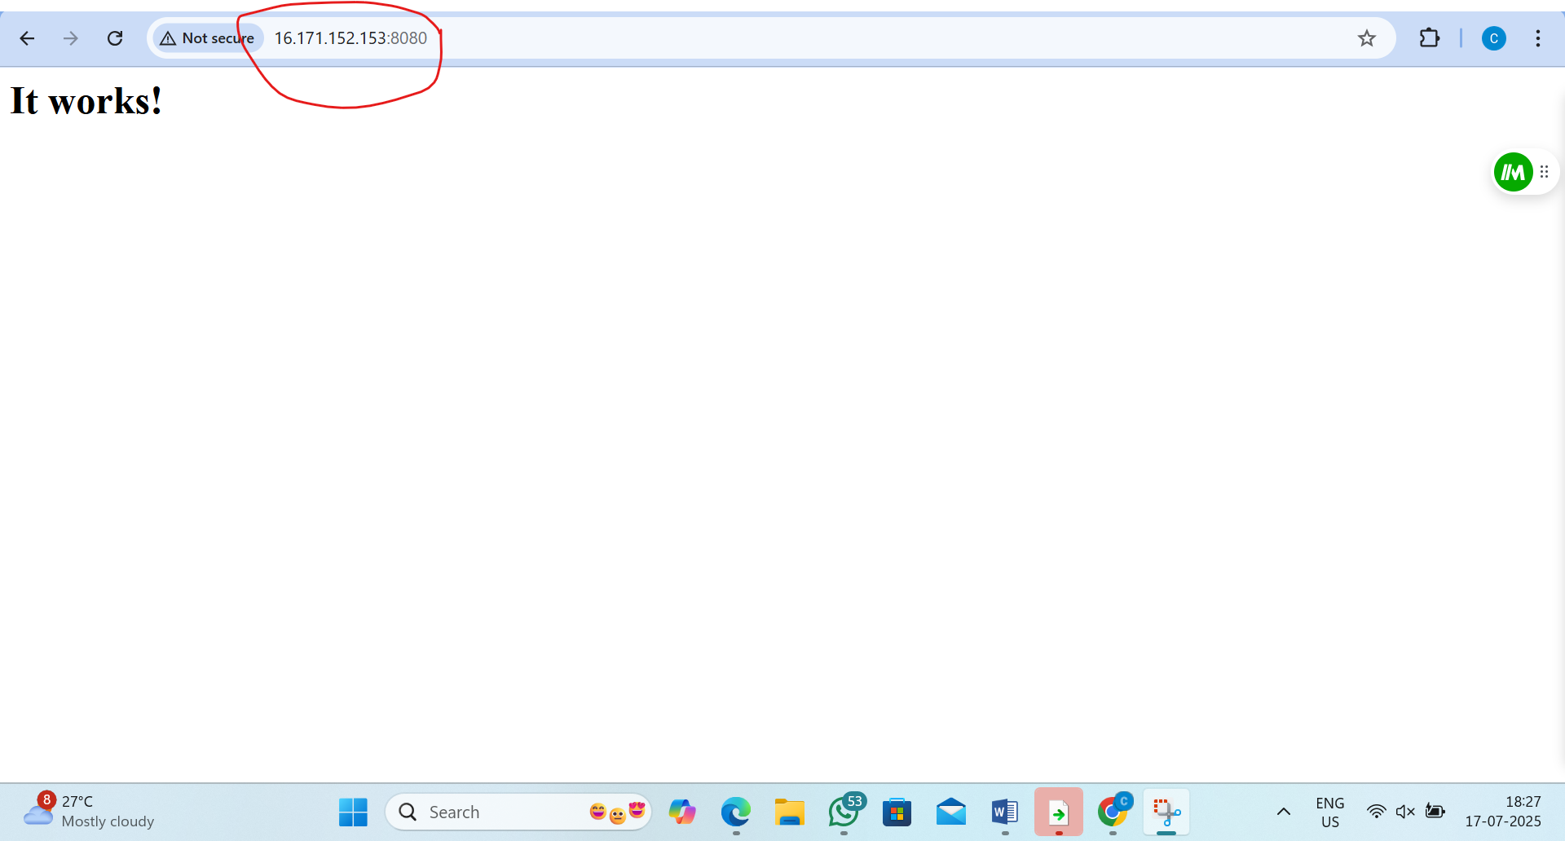

3. L3 - Create Ansible Role to define the task, handler for Nginx Service Installation and invoke the role in Ansible playbook
Step1:go to the roles
by the command:-1) cd /etc/ansible 2)ls 3)cd roles
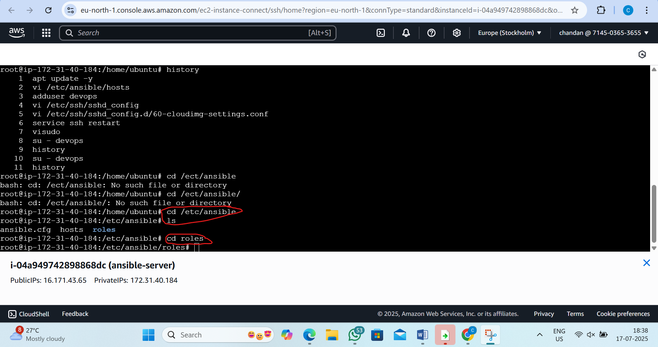
Step2:create the role
by the command:-sudo ansible-galaxy init ngnix
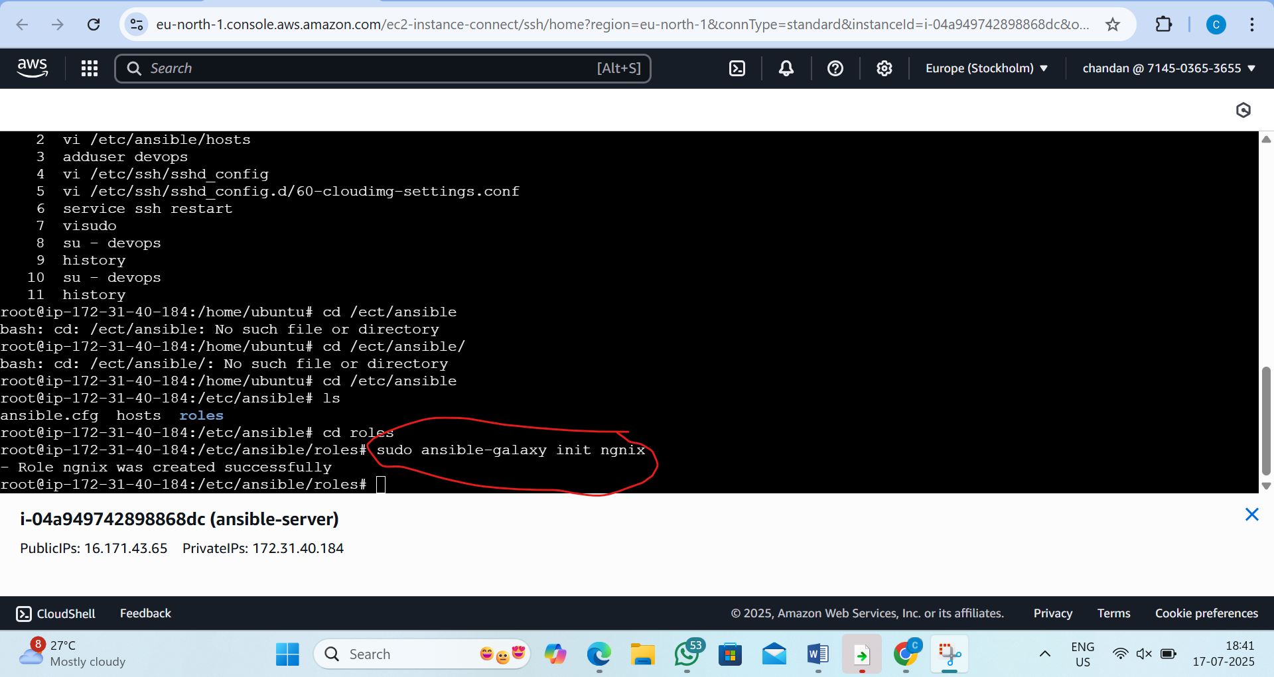

Step3:now list and go to ngnix
by the command :-ls and cd ngnix
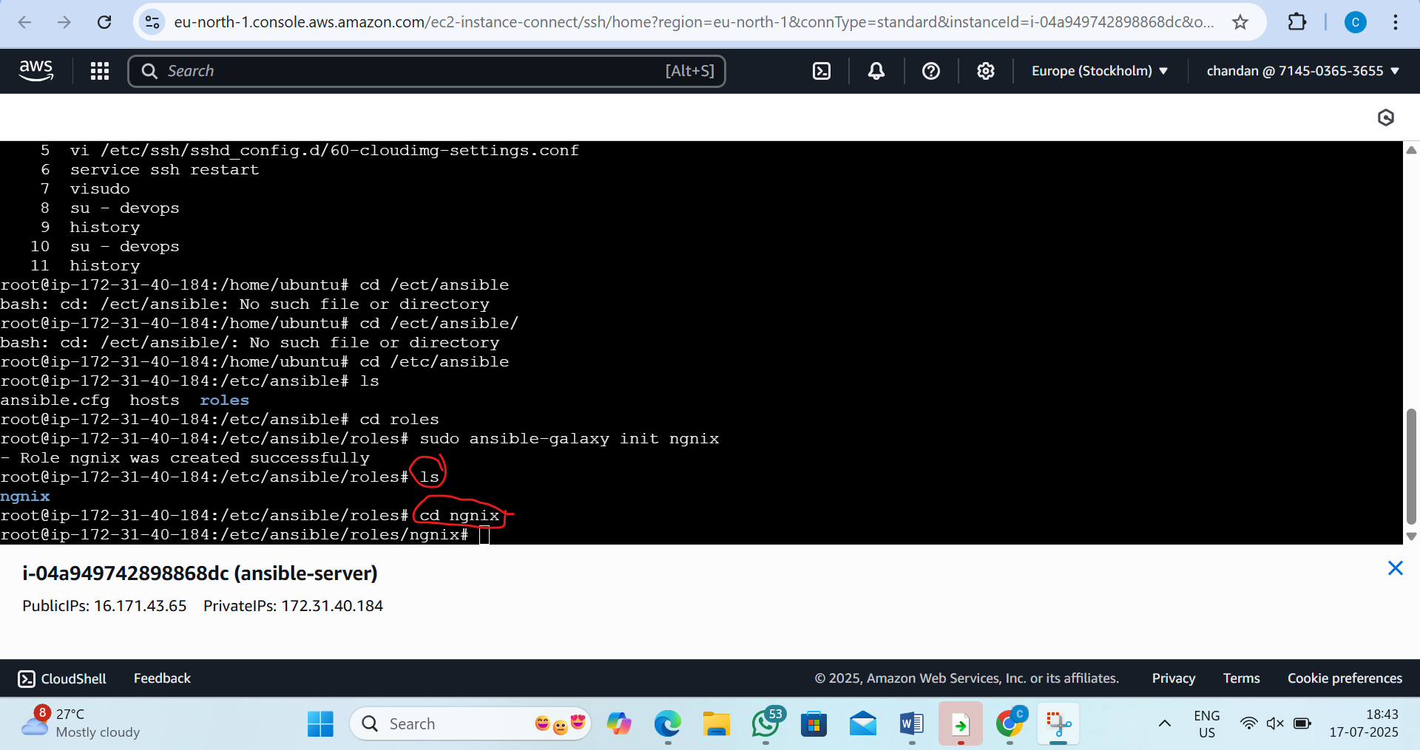
Step4:now ls and got to task file and go to main.yml
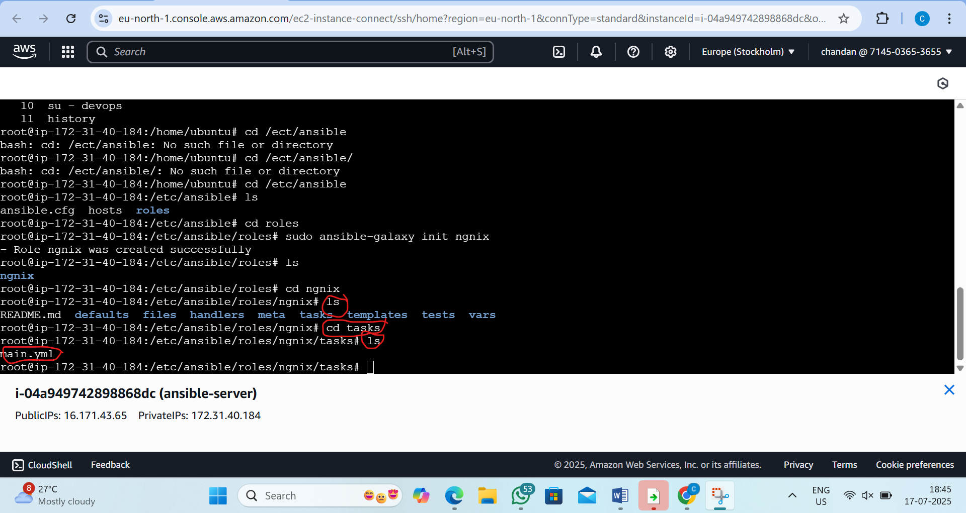

Step5:edit the main.yml file
by the command :- vi main.yml
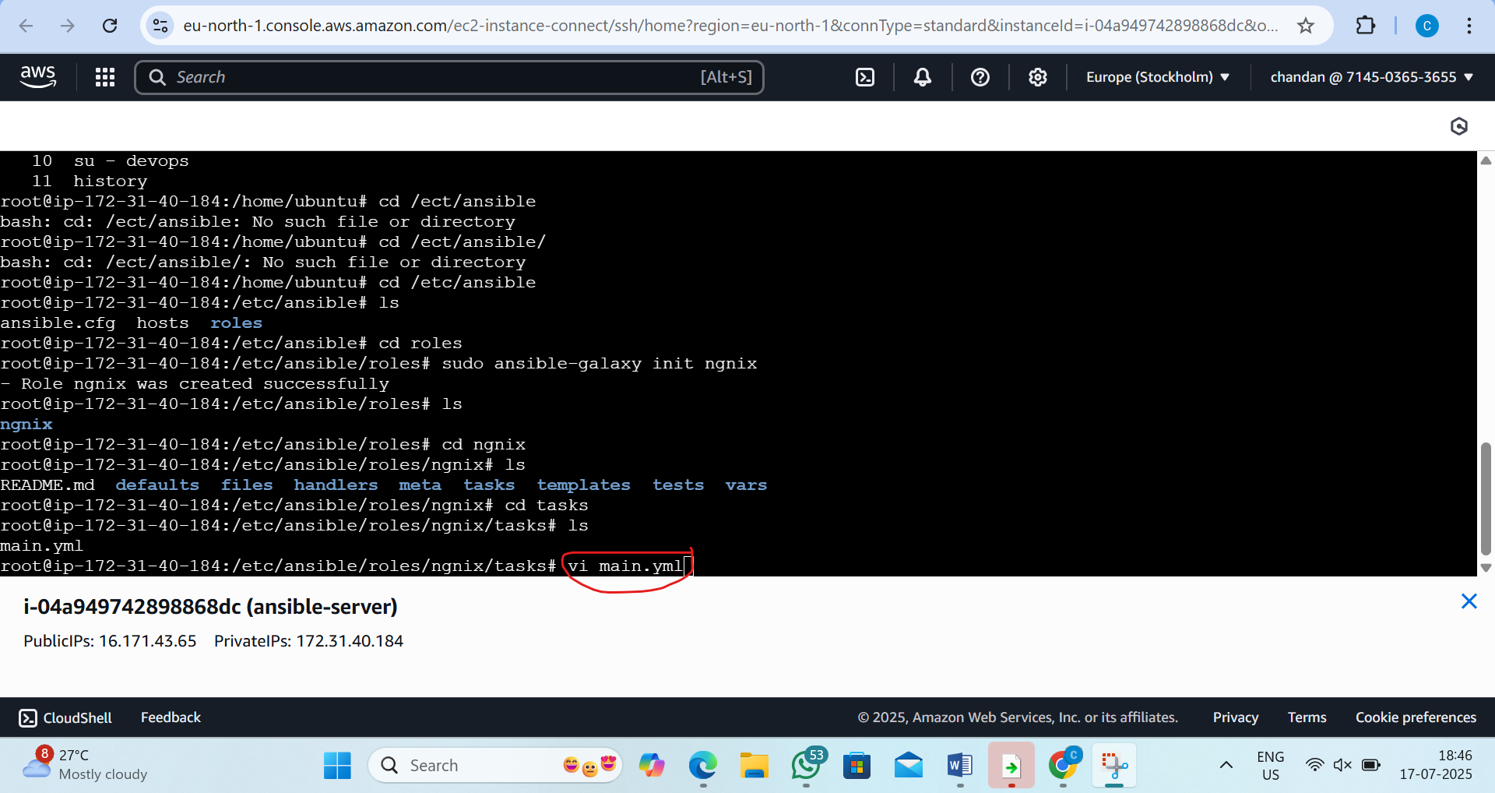
Step6:type the script like this
- name: Install nginx
apt:
name: nginx
state: present
update_cache: yes
notify: restart nginx

- name: Start and enable nginx service
service:
name: nginx
state: started
enabled: yes

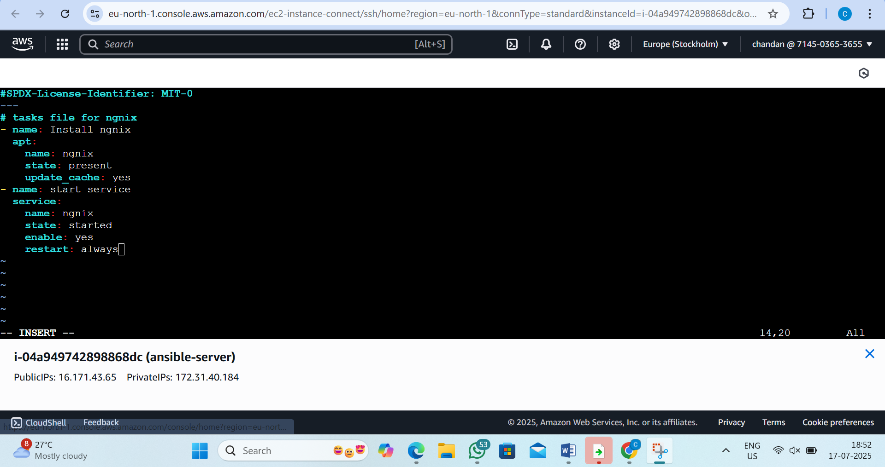

Step7:now come back to home directory and list
By the command:1)cd .. 2)cd /home/devops/ 3)ls
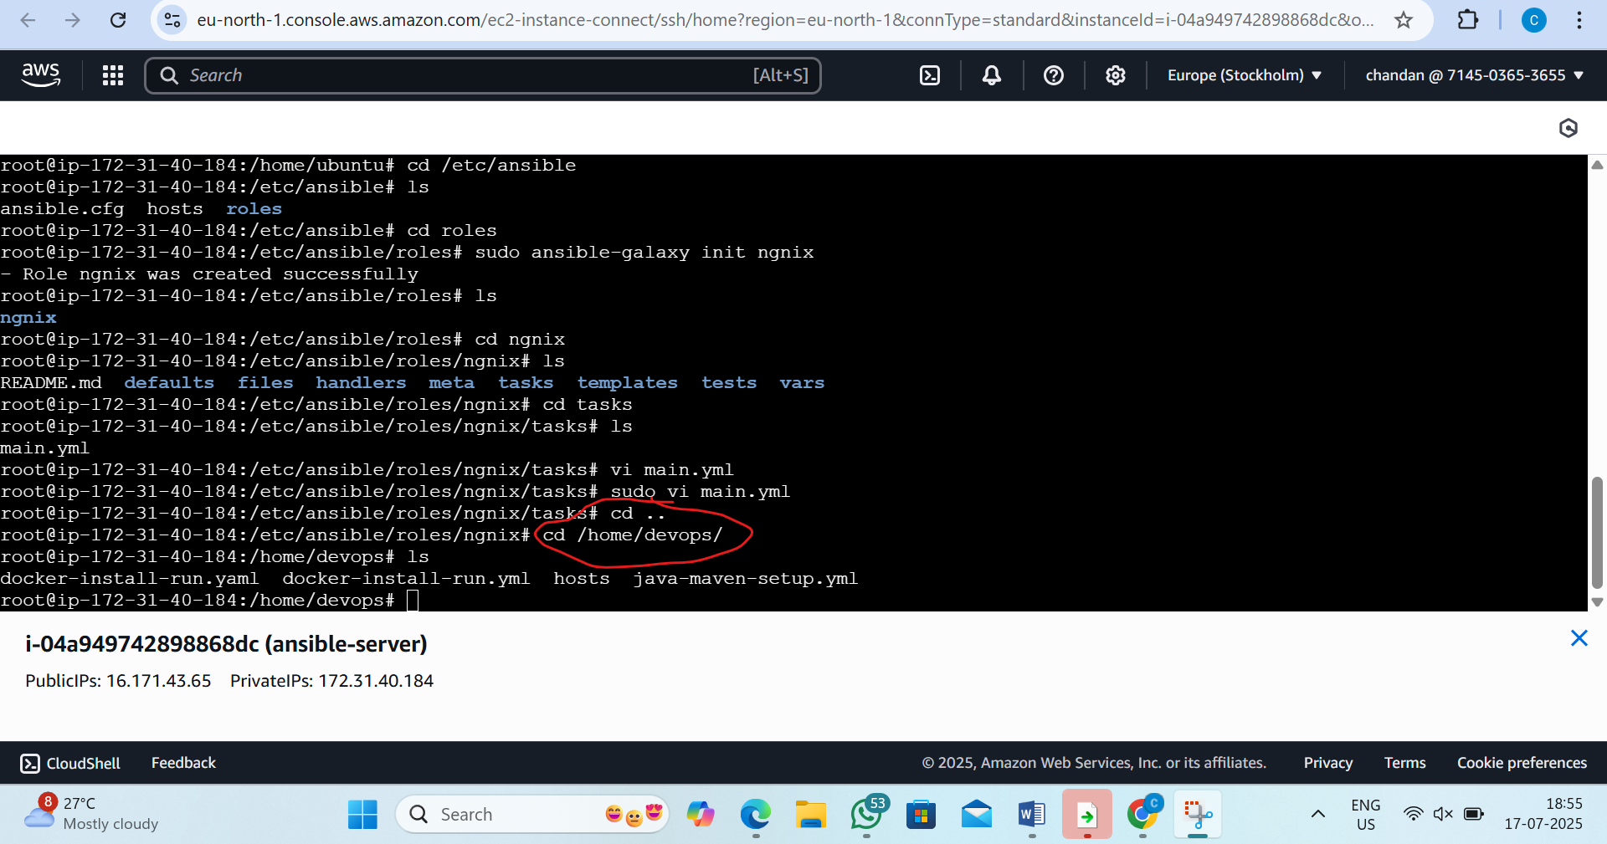

Step8: Add the handler(now edit the handaler file)
By the command:- sudo vi /etc/ansible/roles/ngnix/handlers/main.yml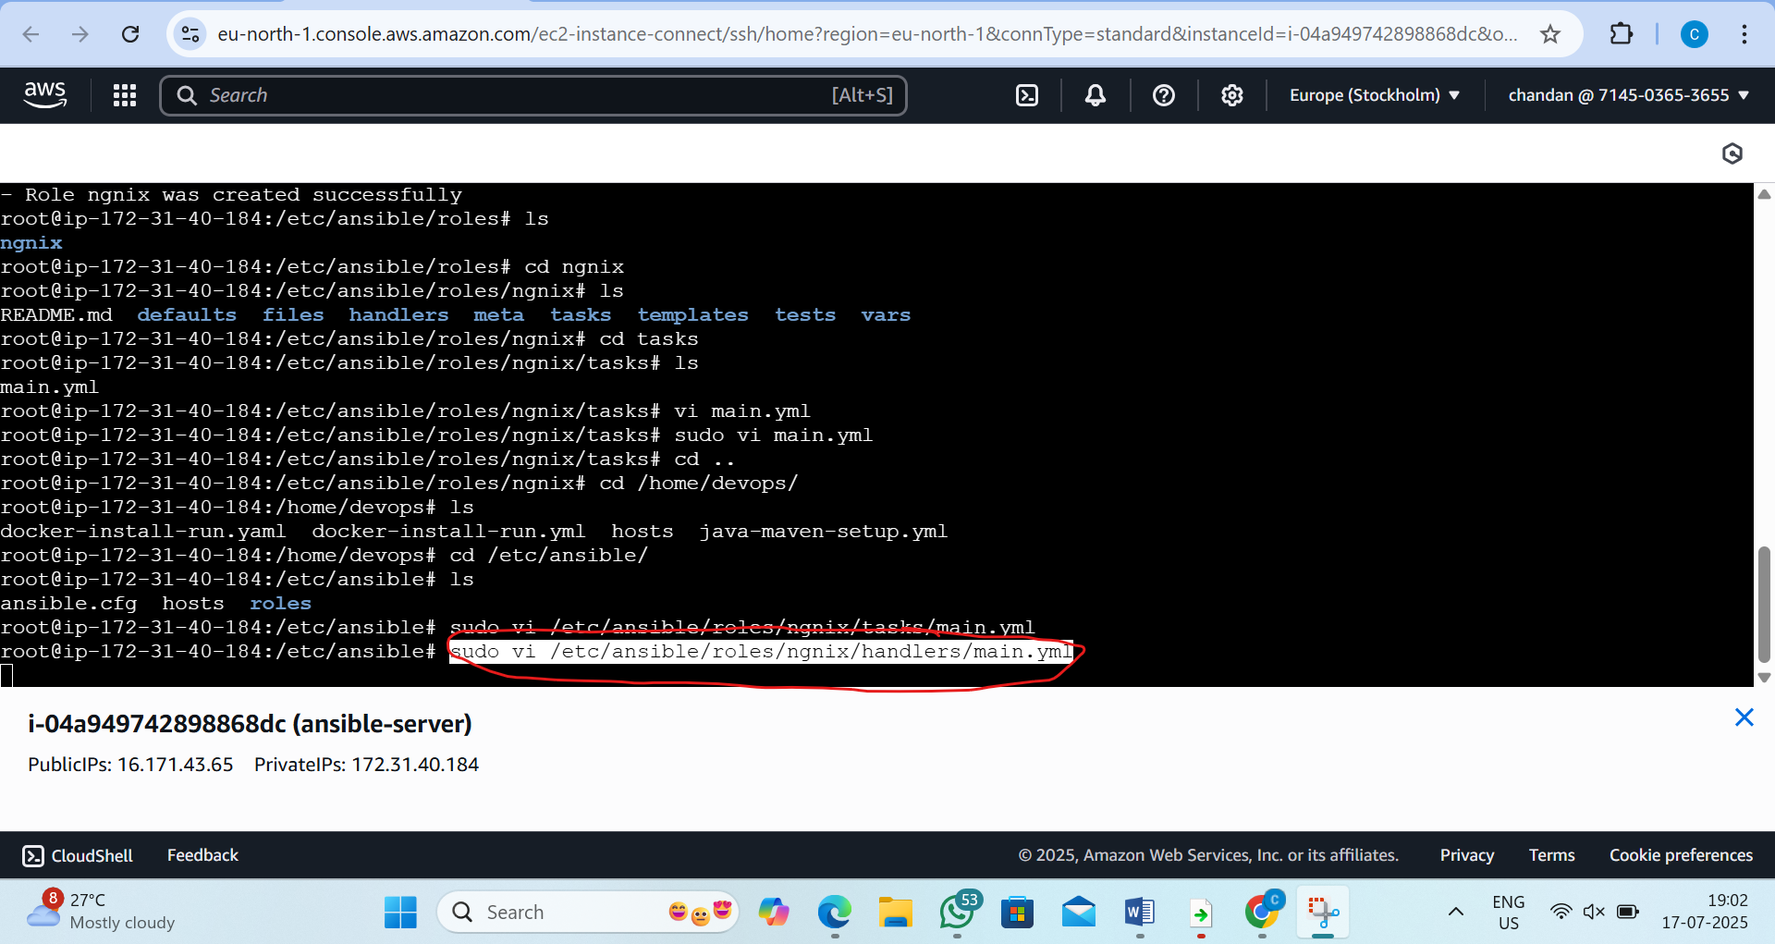
Step9:paste this script inside it
- name: restart nginx
service:
name: nginx
state: restarted
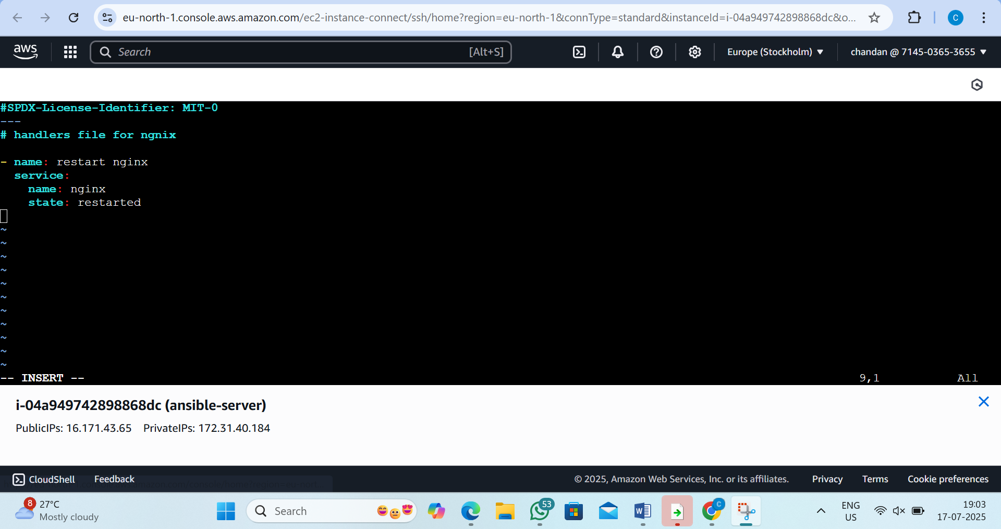

Step10: Create main playbook to invoke the role
By the command: 1)cd /etc/ansible
2)sudo vi nginx-role-playbook.yml
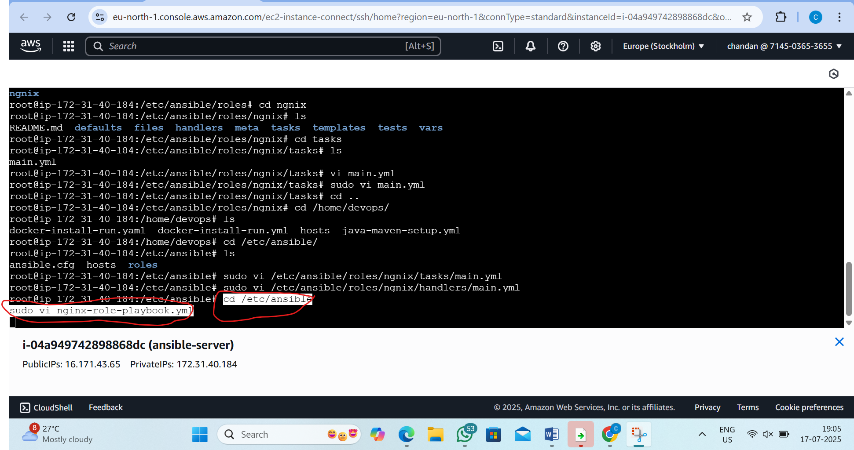
Step11:paste this script inside
- name: Install and Manage Nginx using Role
hosts: nodes
become: yes
roles:
- ngnix
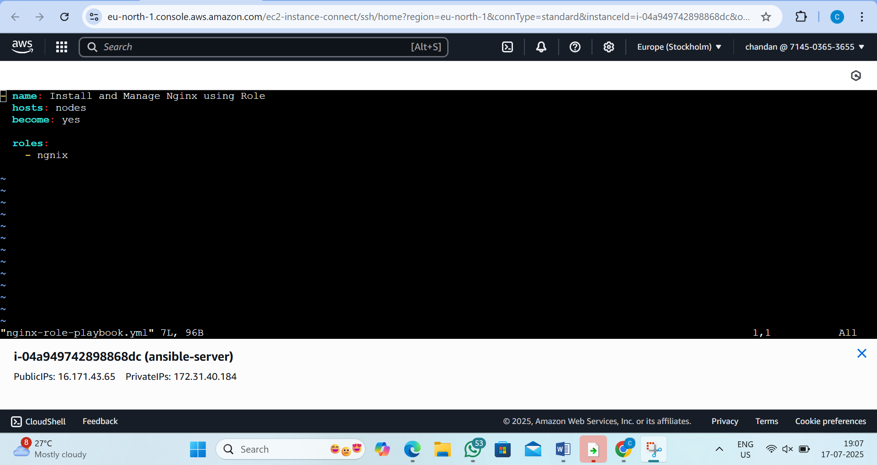
Step12: now run the playbook
by the command: 1)cd /etc/ansible
2)ansible-playbook nginx-role-playbook.yml
